English 14.1.22
Pick 5 adjectives to describe the polar bear.
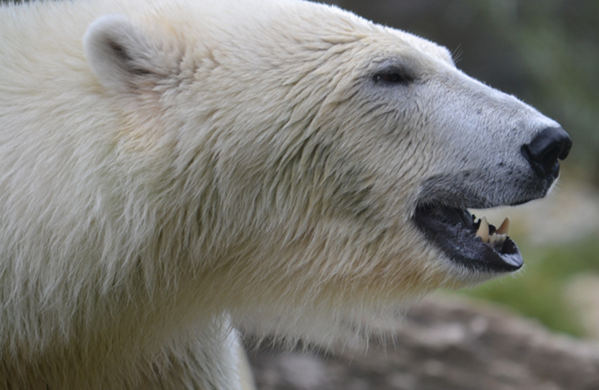

- ________________

- ________________

- ________________

- _________________

- _________________

Now use these adjectives to write a description of the polar bear.

