New Spellings – SS group

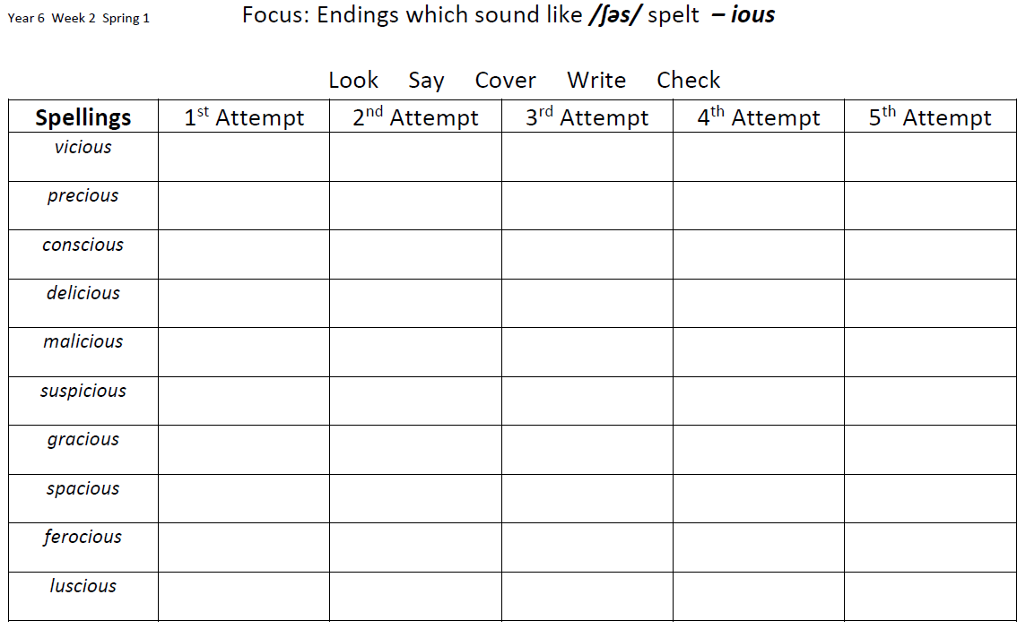
Mrs Bird’s group
official
special
artificial
confidential
essential
torrential
partial
crucial
palatial
facial

