New Spellings – SS group

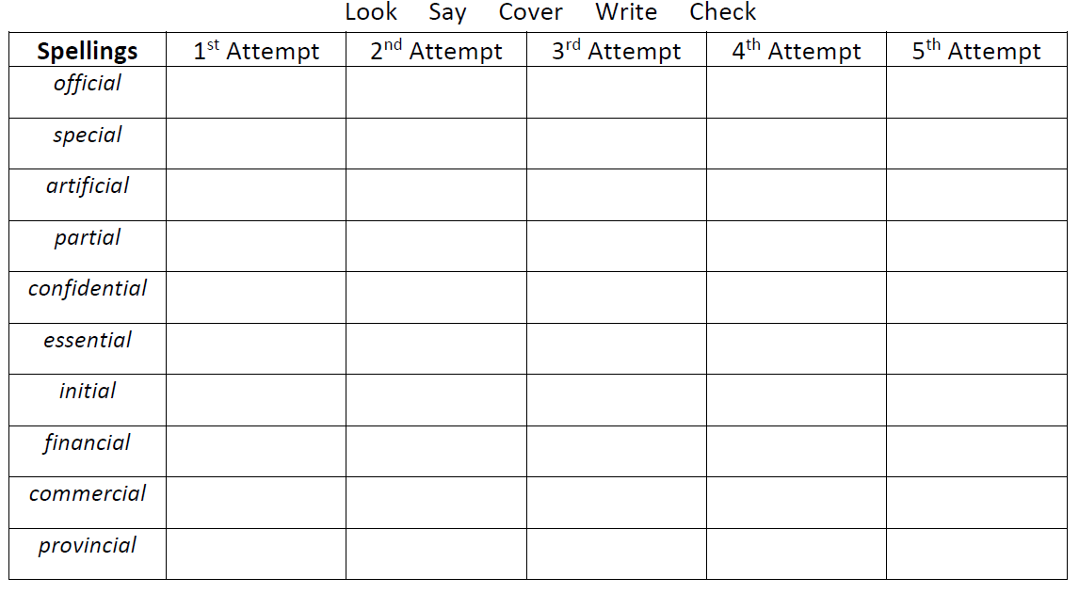
Mrs Bird’s group
sensibly
possibly
considerably
enjoyably
reliably
terribly

