Squirrels Homework – 07.01.2021
English
This term, our book is ‘Ready, Steady, Mo.’
Please watch the story with your adult: https://www.youtube.com/watch?v=lwYROLGGsSo

Activity:
Please look at the picture below.
Please write 3 sentences about what you can see.
Have a go at beginning your sentences with - ‘I can see…’
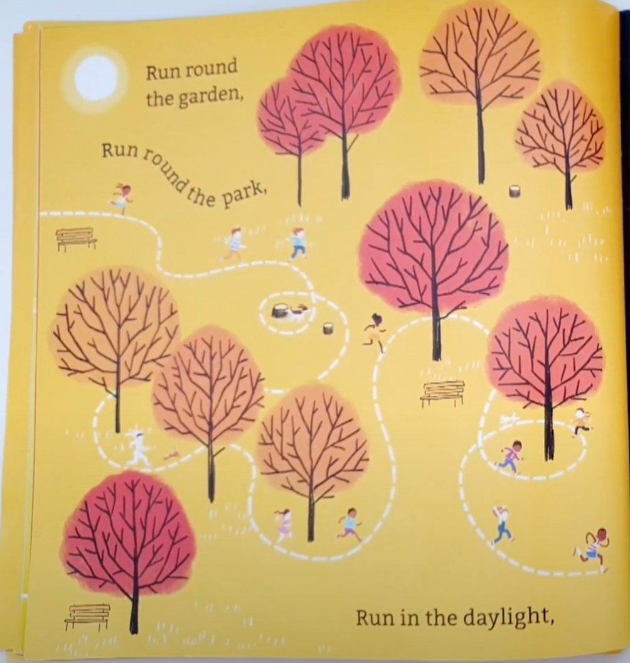

Challenge: Can you use an adjective in your sentence?

