Squirrels Homework – 14.01.2022
English
We have been reading the story ‘Ready, Steady, Mo.’ Please rewatch the video to remind you of the story.
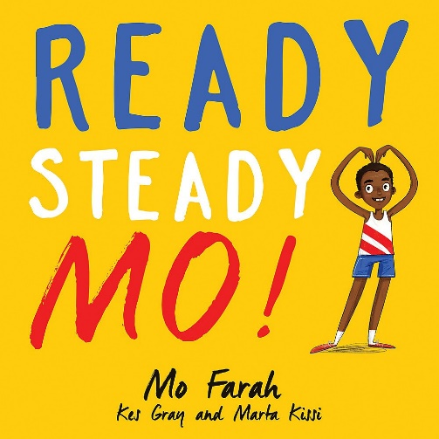
https://www.youtube.com/watch?v=lwYROLGGsSo

Think about what journey you would take if you were running just as Mo is in the story.
Please write 3 sentences (or more) and draw pictures of the places that you visit on your journey.

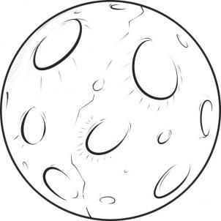
Example:
Run to the bright moon.

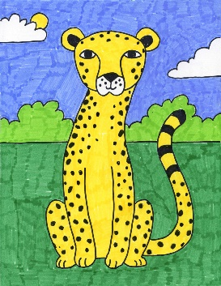

Run with a spotty cheetah.

Run up the tallest mountain.

Read Write Inc Sounds Practise:
