Squirrels Homework – 07.01.2022
Maths
Please complete the questions below:
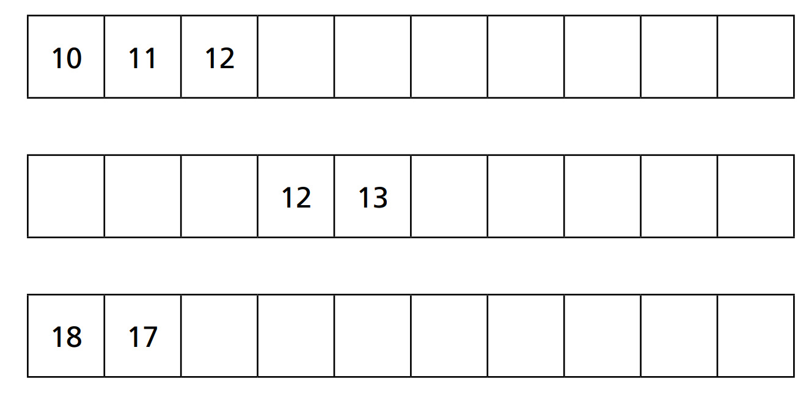
1.

2. Complete the table.
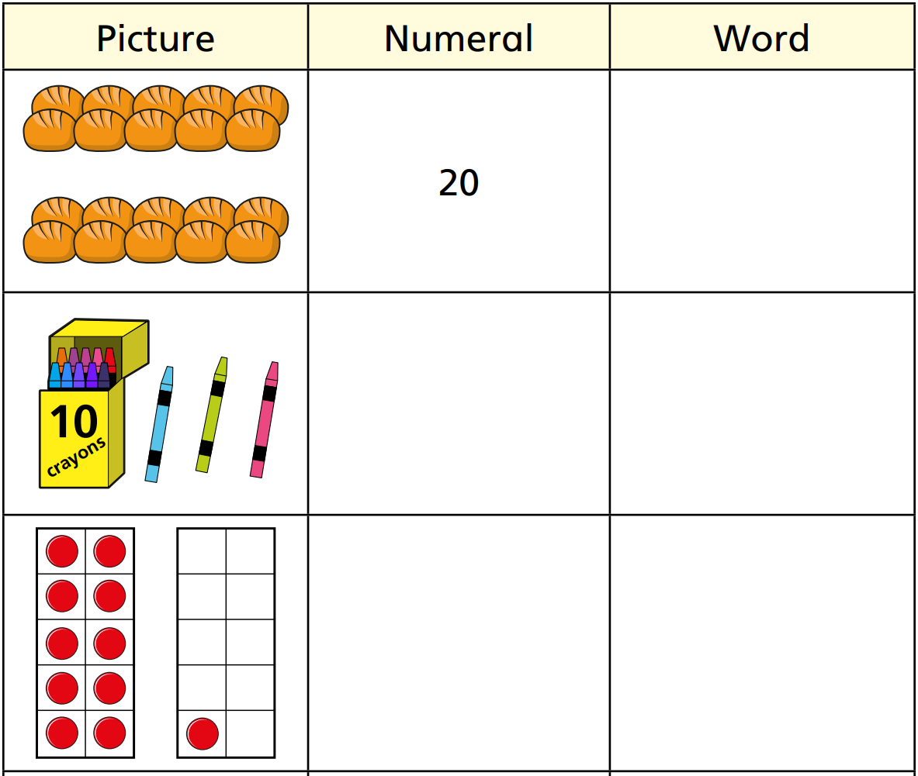

3. How many apples are there?

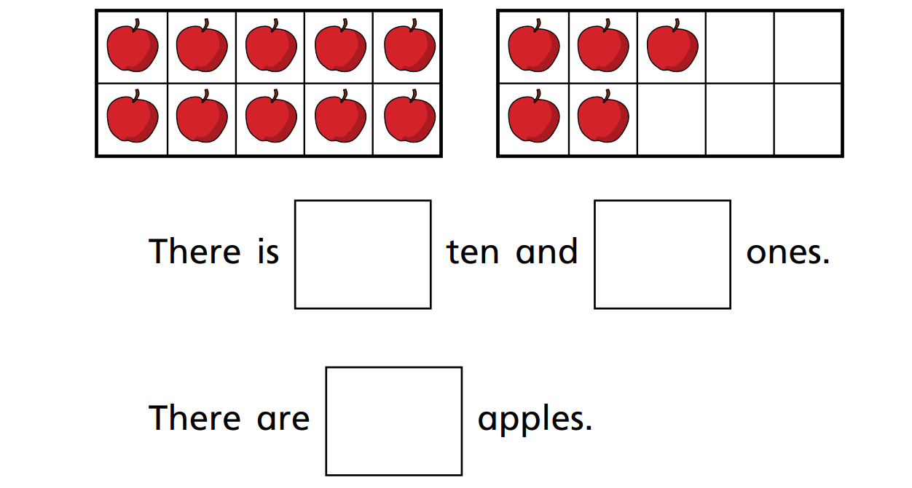

Challenge:
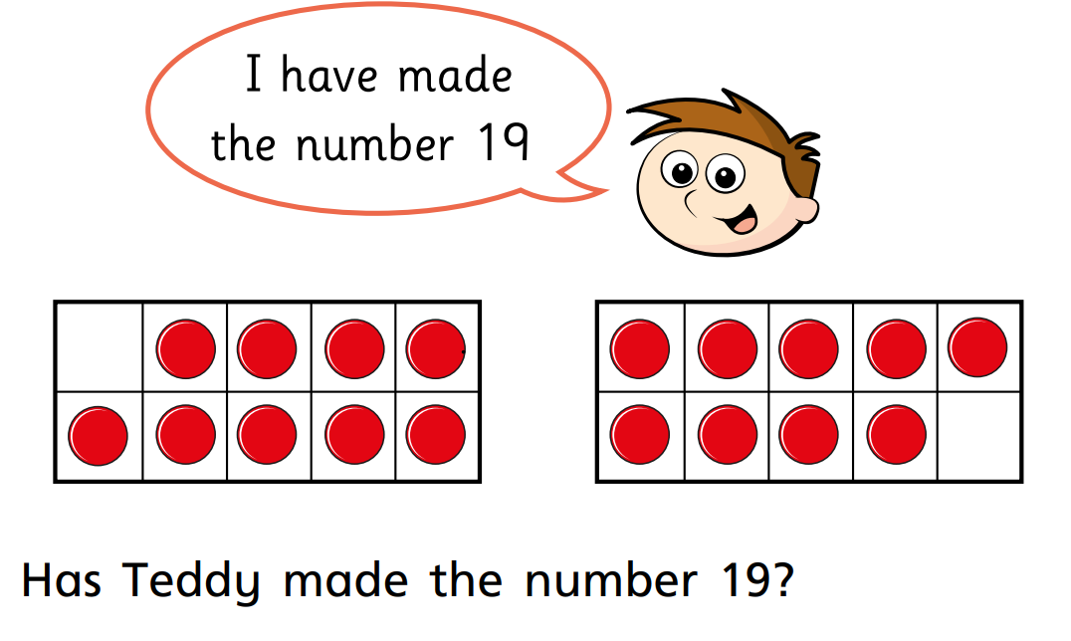
Can you show 19 in another way?

