Squirrels Homework – 14.01.2022
Maths
1. Tom has 12 sweets. Miss MacMillan eats 1.
How many does he have left?

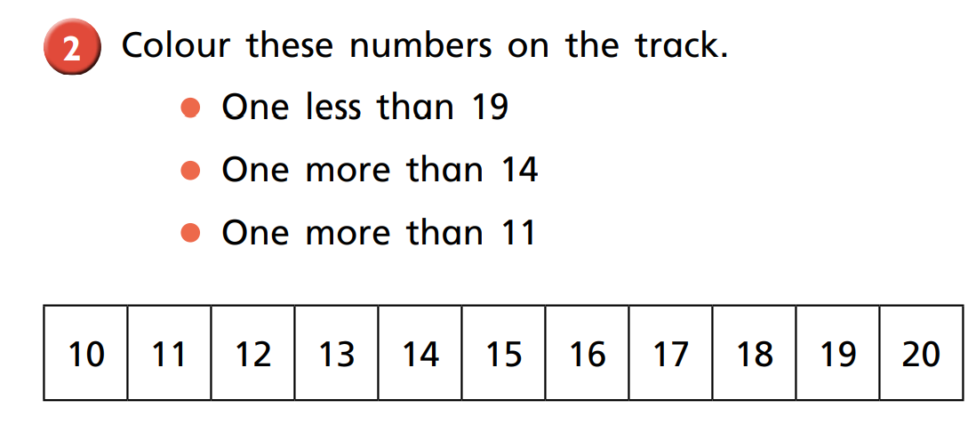
2.
14a
18a
17a

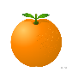
3. Ben and Mel have these oranges:
Ben:
Mel:

Who has the most? ______________

is more than
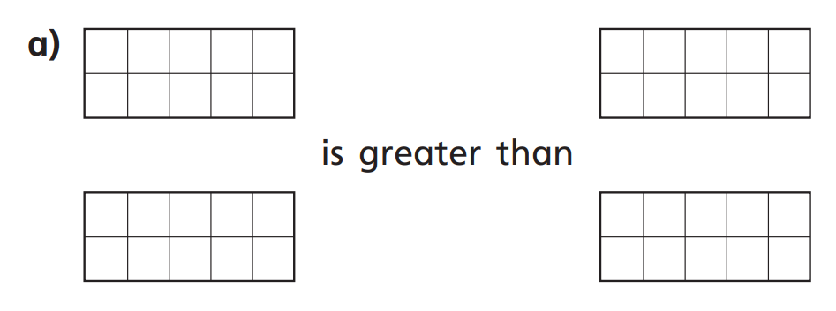
4. Fill in the ten frames to make each statement correct.

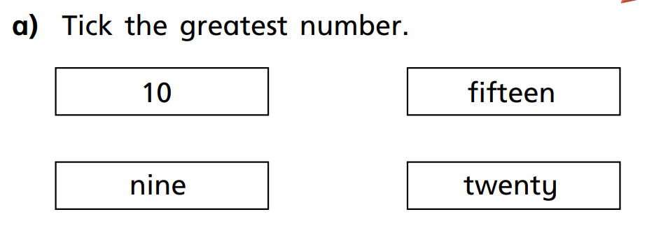
5.

