Squirrels Homework
Maths
Please answer the questions below:
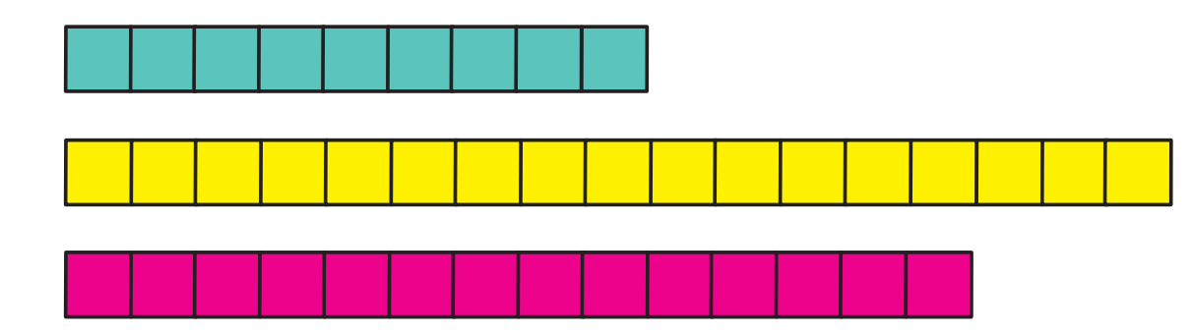
1. Look at the towers below and count how many is in each one, then answer the questions underneath:

- Which number is the smallest?

- Which number is the greatest?

- Please write the numbers from greatest to smallest.

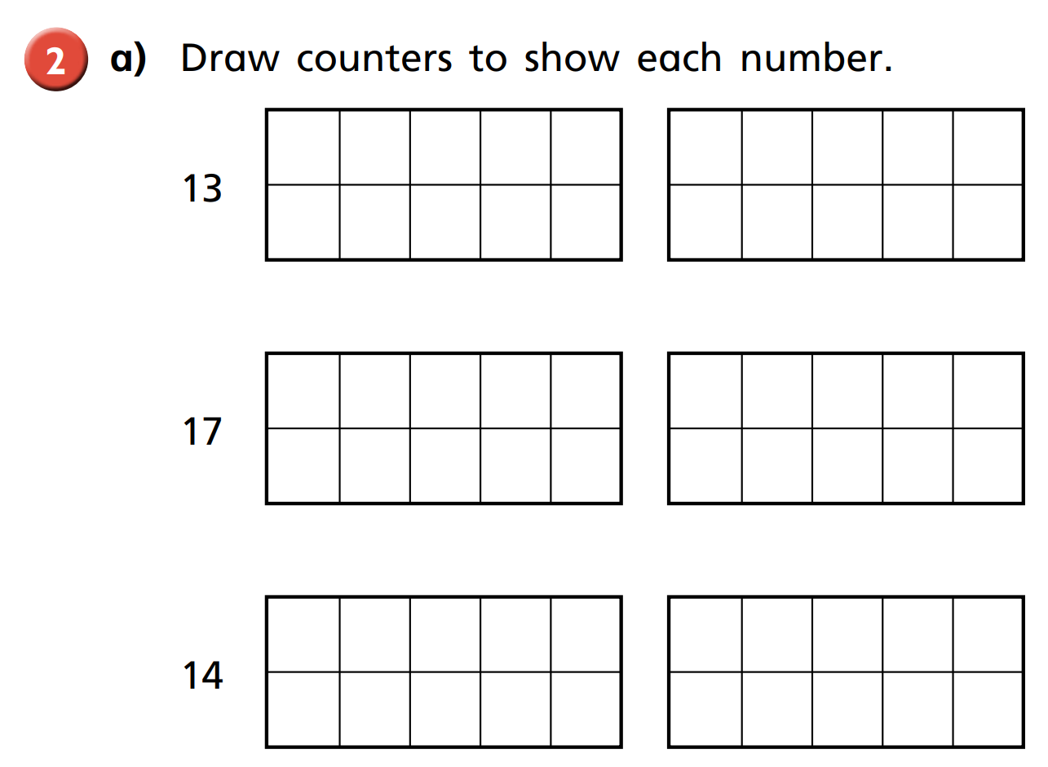
2.

- Write the numbers in order starting with the smallest.

- Write the numbers in order starting with the greatest.

- What do you notice?

3. Fill in the missing phrase:
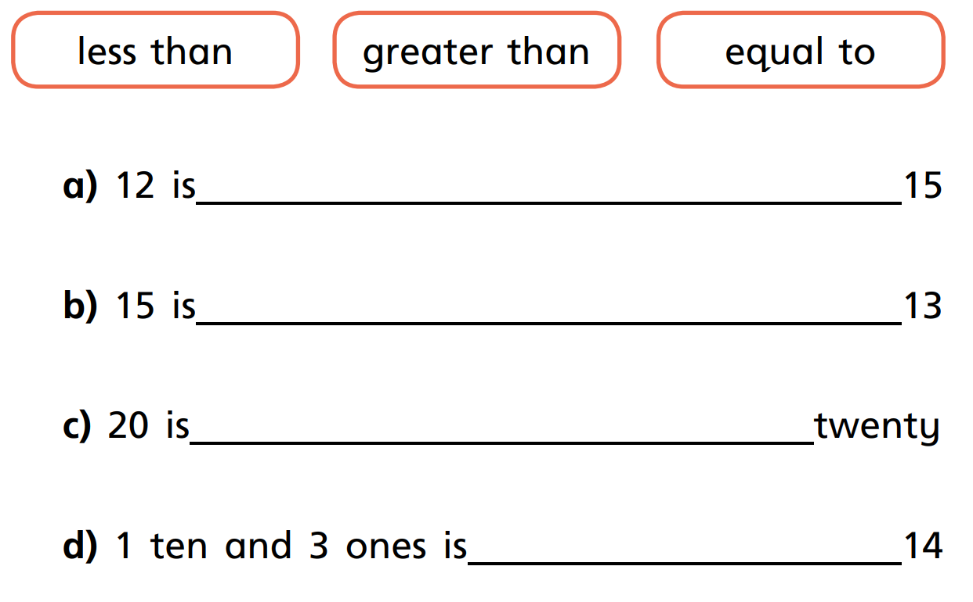

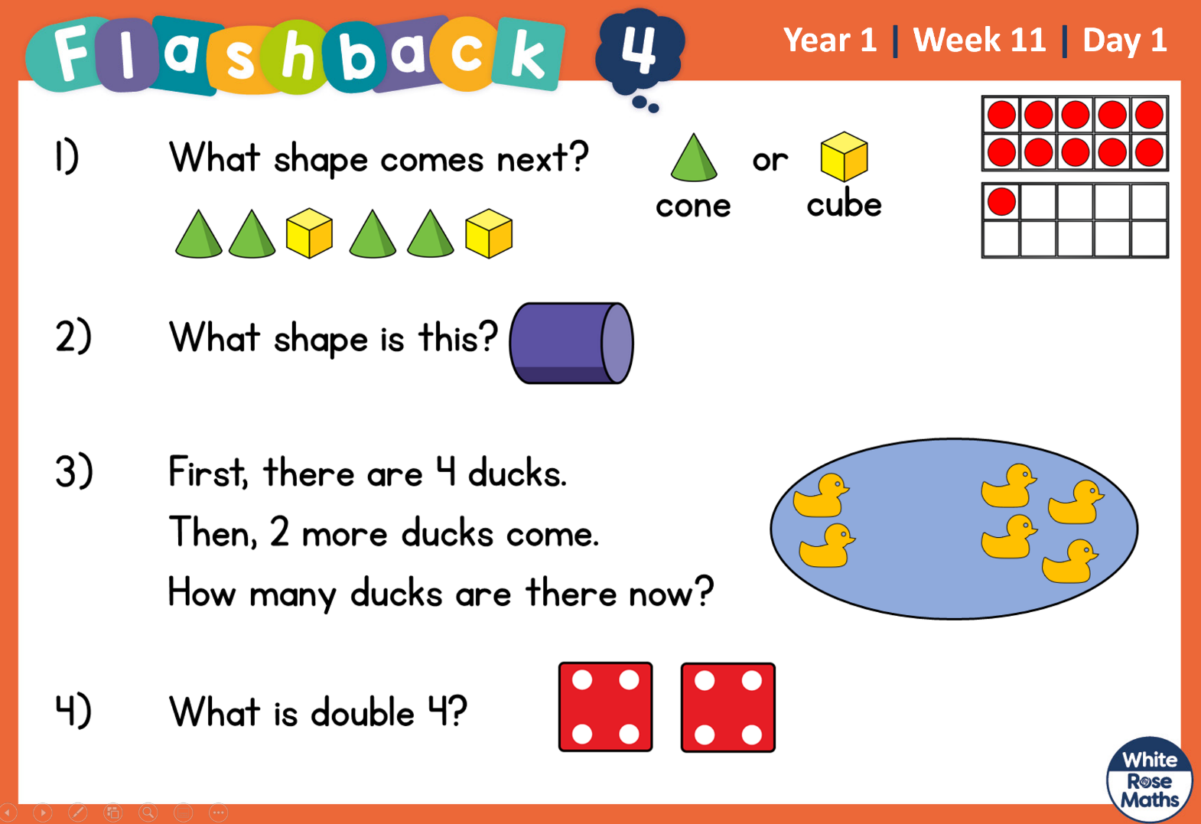
Recap:

