Friday 14th January 2021
English – Homework
Can you spot and correct the punctuation mistakes in the passage another Year 4 child wrote below?
to begin, it took 70 days to prepare a mummy once you finish your mummy, they placed it in a sarcophagus and then put it in one of their pyramids Usually it was covered in glistening gold they took out all the organs except the heart and put them in Canopic jars. to summarise it takes 70 days to finish the mummification process because when they put the egyptian in the natron salt, it took 70 days for all the water to get out of the body
Task 2.
Write in full sentences, complete with capital letters and full stops at least five interesting facts about Ancient Egypt.

Friday 14th January 2021
Maths homework
Please practise your 4x table to make sure you can recall the facts speedily. If you are confident then spend 5 to 10 minutes practising a table of your choice. Here is the link to the song we’ve been using and the link to hit the button, a times table game.
Song: https://www.youtube.com/watch?v=8QU_E0u-tP4
Hit the button: https://www.topmarks.co.uk/maths-games/hit-the-button

Then choose either A, B or C depending on how confident you feel from the tasks below.

A
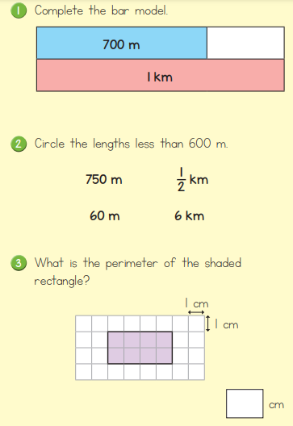
B
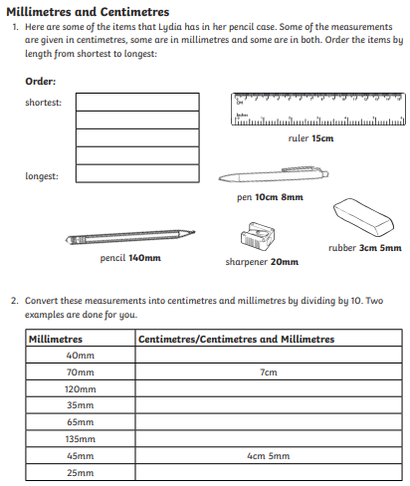

C
