Week 3 – Maths homework

Remember to spend 5-10 minutes focussing on your timestables. If you still need to practise your 8x table this is the link https://www.youtube.com/watch?v=z_BJjR9rdwA. If you are confident then find 2 dice, roll them and multiply the number by your chosen table. See how many you can answer in 5 minutes, or try 1 minute of 6, one of 7x, one of 8x etc. Which one can you answer the most of?
Answer A, B OR C, there’s no need to answer all 3 sections.

A

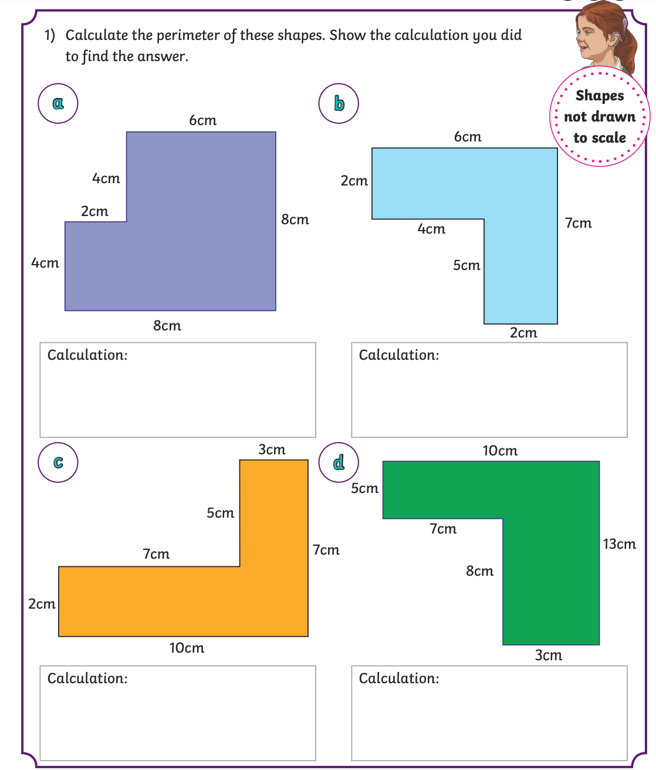

B

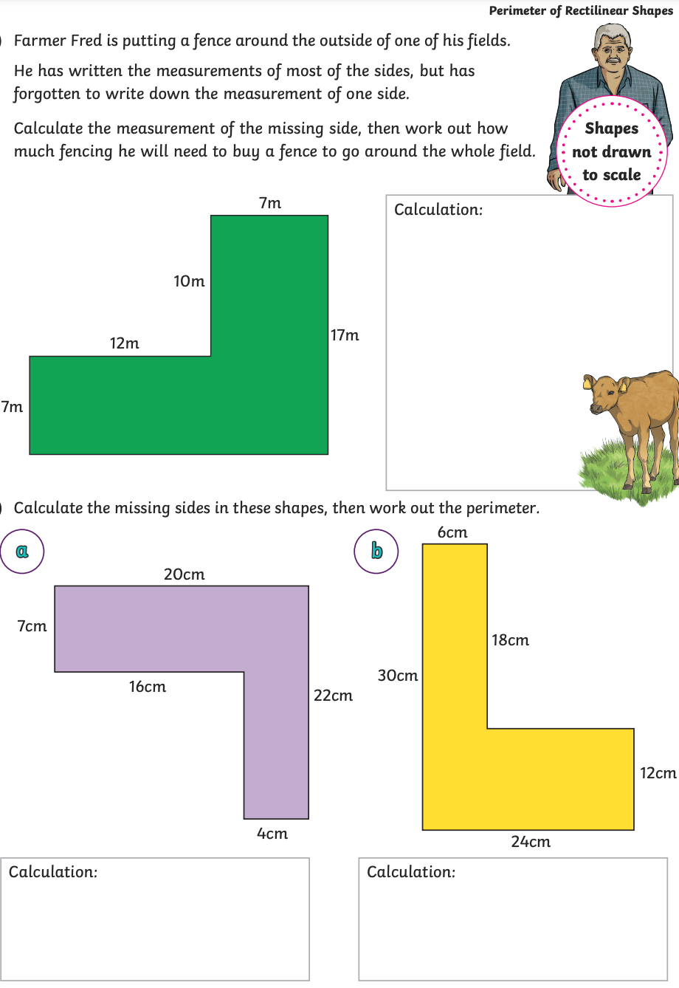
C
