Maths 25.2.22

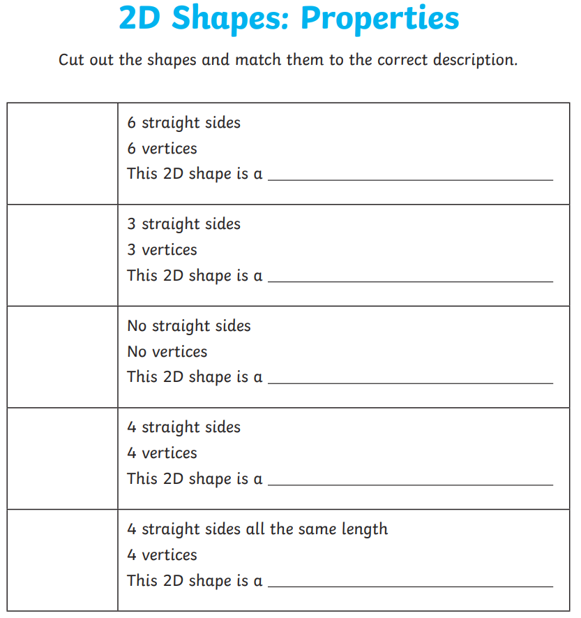
Can you draw…

A rectangle ________________________

A pentagon _________________________

An octagon __________________________

