Spellings
Mrs Siddiqui’s group
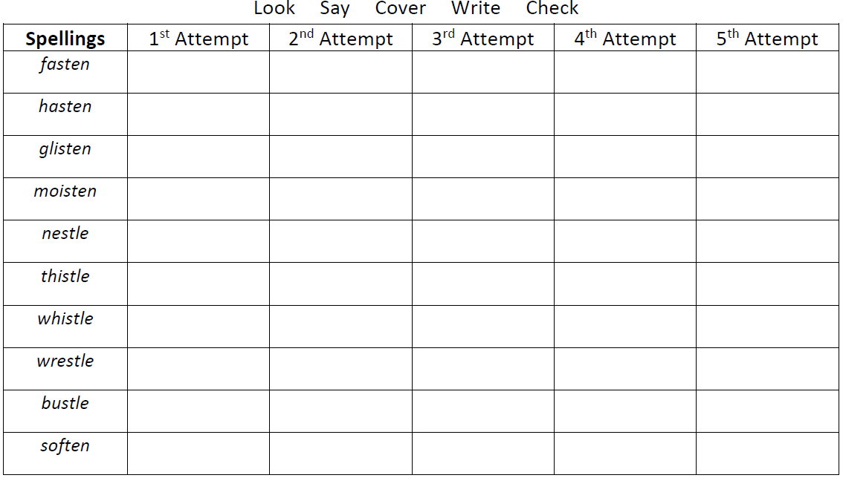
Mrs Siddiqui’s group (2nd set)
Spellings
aggressive
attached
communicate
opportunity
guarantee
profession
sufficient
harass
necessary
embarrass

Spellings- Mrs Bird’s group
Spellings
interfere
interrupt
interact
international
interested
independent

Ms Jones and Ms Dowsett’s group
Spellings
jacket
energy
they’re
giraffe
hutch
sketch
annoy
instead
fresher

