English 4.3
Re write these sentences putting a capital letter and full stop in the correct place.
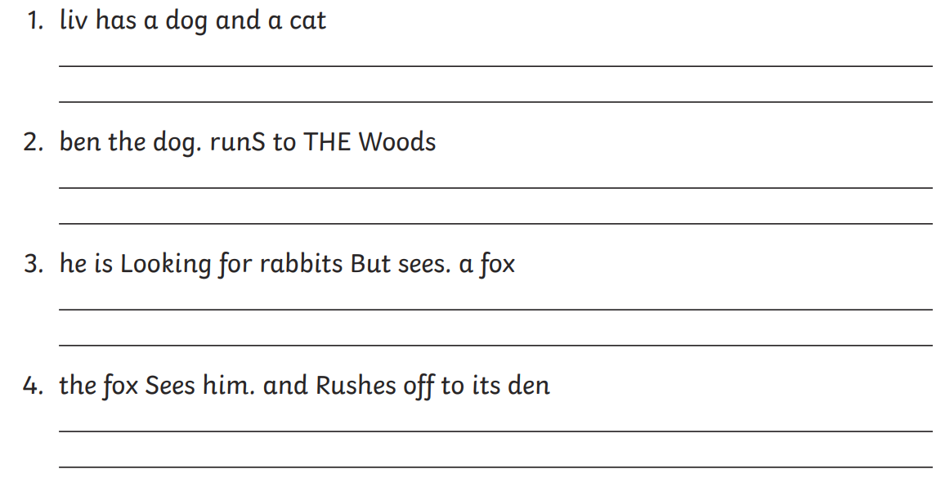

Challenge
