**Spend about 20-30 minutes a week on the questions – you do not need to do them all.**

**Choose questions that you need to practice from the left side, or try the challenge question on the right**

**Number and Place Value**

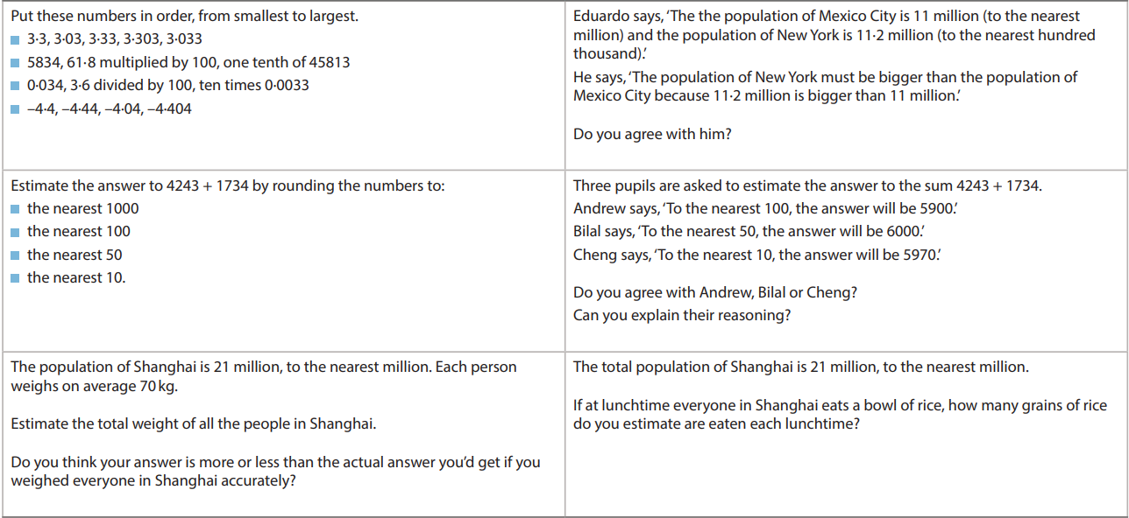

**Addition and Subtraction**

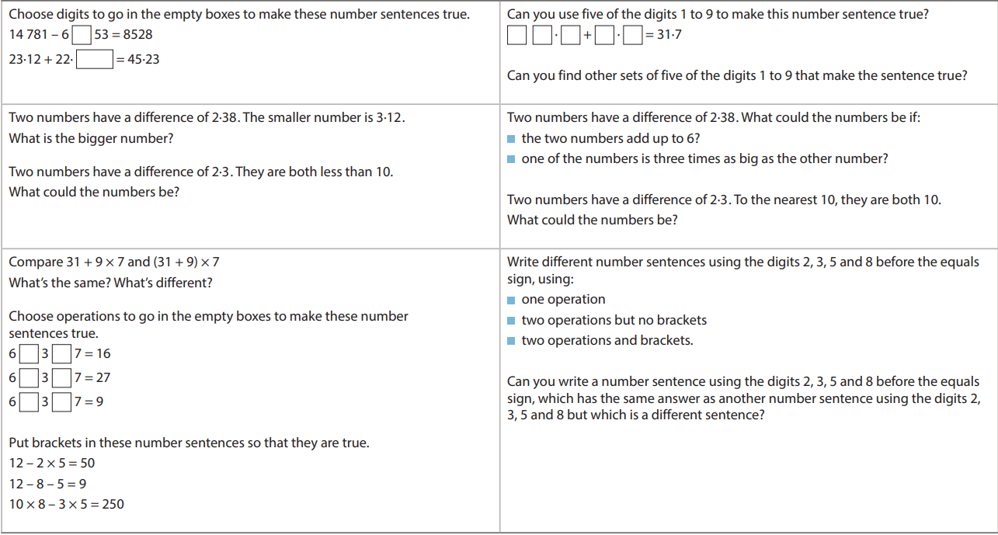

**Multiplication and Division**

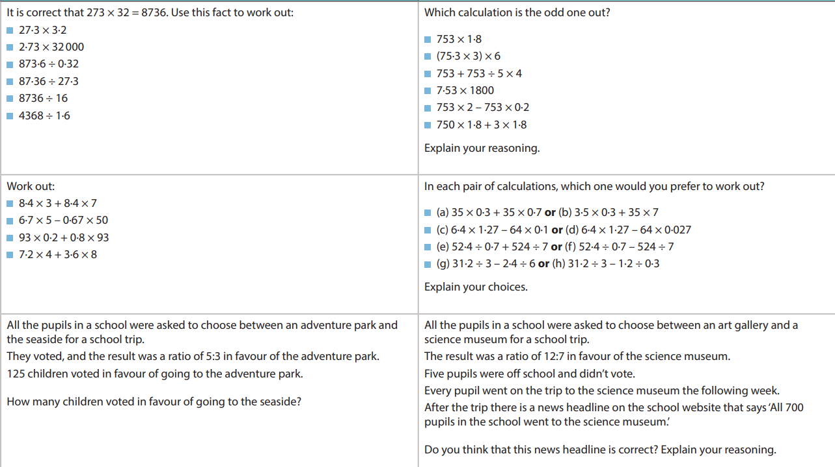

**Fractions and Decimals**

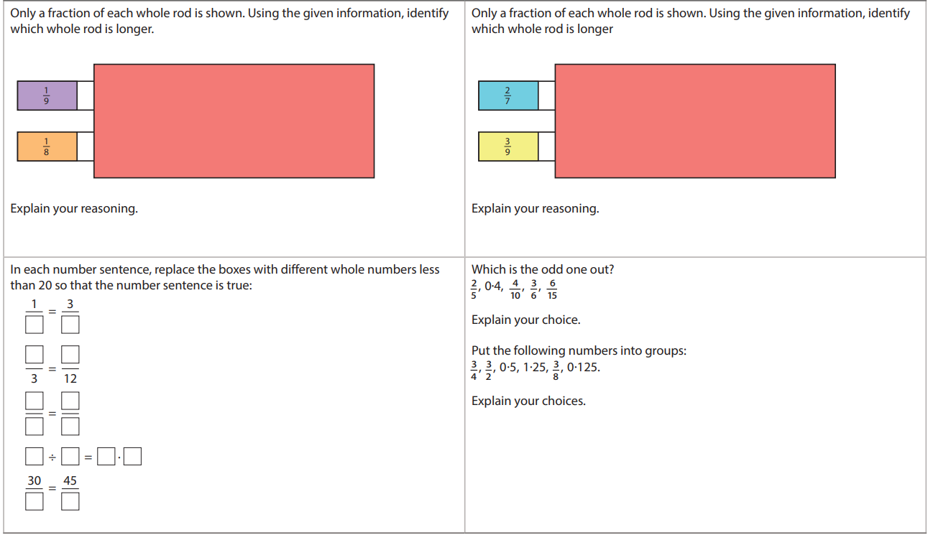

**Ratio and Proportion**

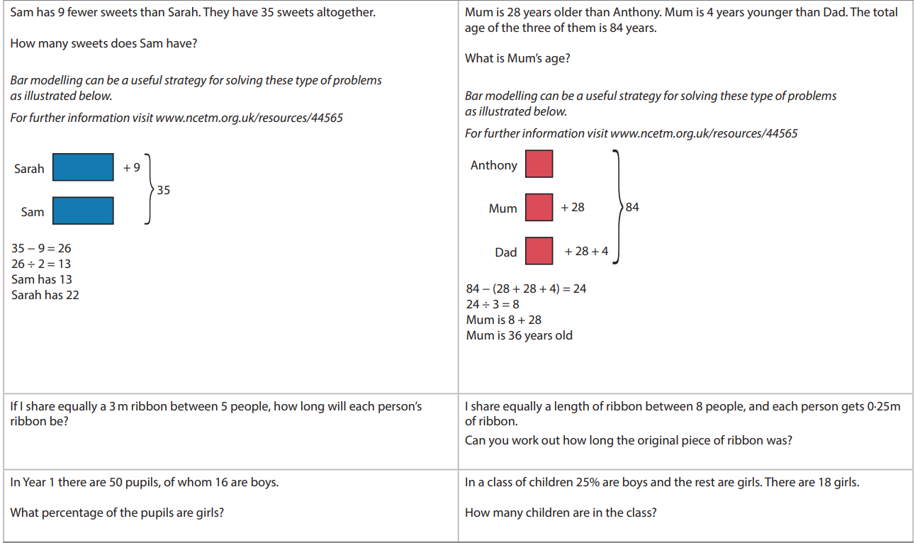

**Measurement**

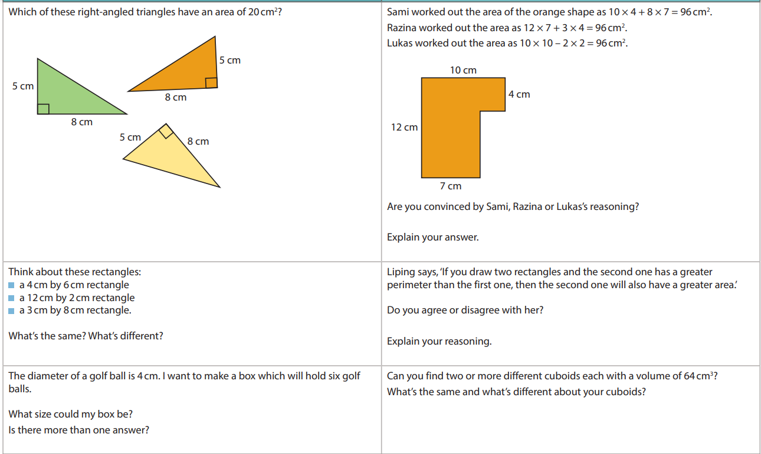

**Shape**

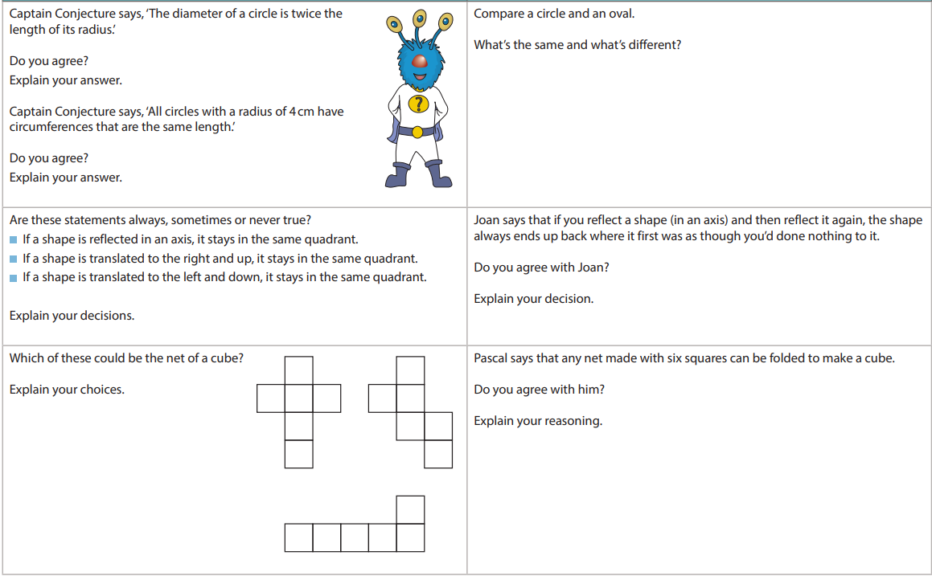

**Statisitics**

