Spellings
Mrs Siddiqui’s group
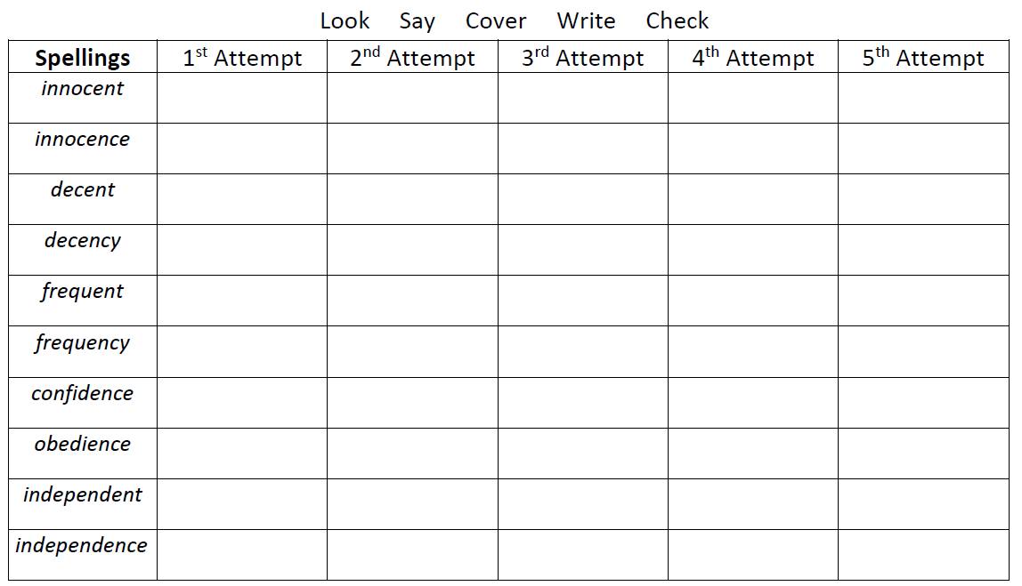

Spellings- Mrs Bird’s group
Spellings
innocent
decent
confident
obedient
different
impatient

Ms Jones and Ms Dowsett’s group
Spellings
quality
quantity
quarry
wander
would
wallet
sugar
squash
could
wasp

