Spellings
Mrs Siddiqui’s group
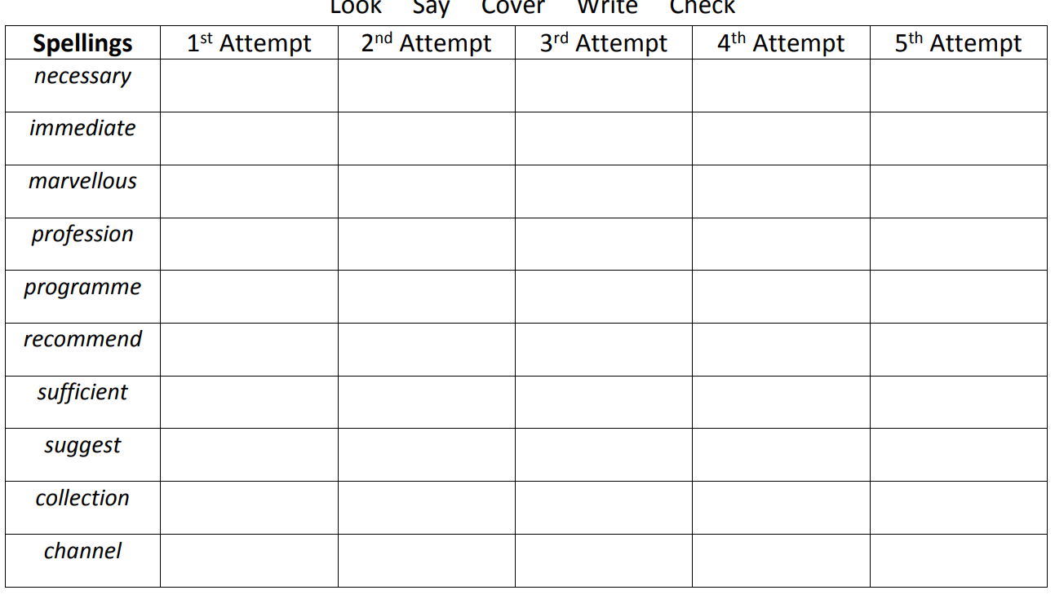
Mrs Siddiqui – extra spellings
especially, bruise, amateur, leisure, nuisance, privilege

Spellings- Mrs Bird’s group
Spellings
observant
tolerant
assistant
resistant
signification
reluctant

Spellings

