Spellings
Mrs Siddiqui’s group
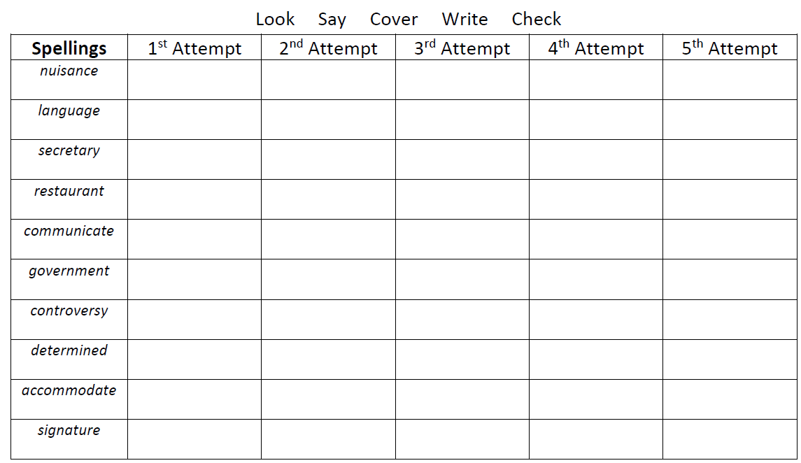

Spellings- Mrs Bird’s group
Spellings
important
together
those
finally
suddenly
thought
heard

Ms Jones and Ms Dowsett’s group

Spellings
engagement
station
solution
section
motion
creation
nation
caution
employment
position

