Spellings
Mrs Siddiqui’s group
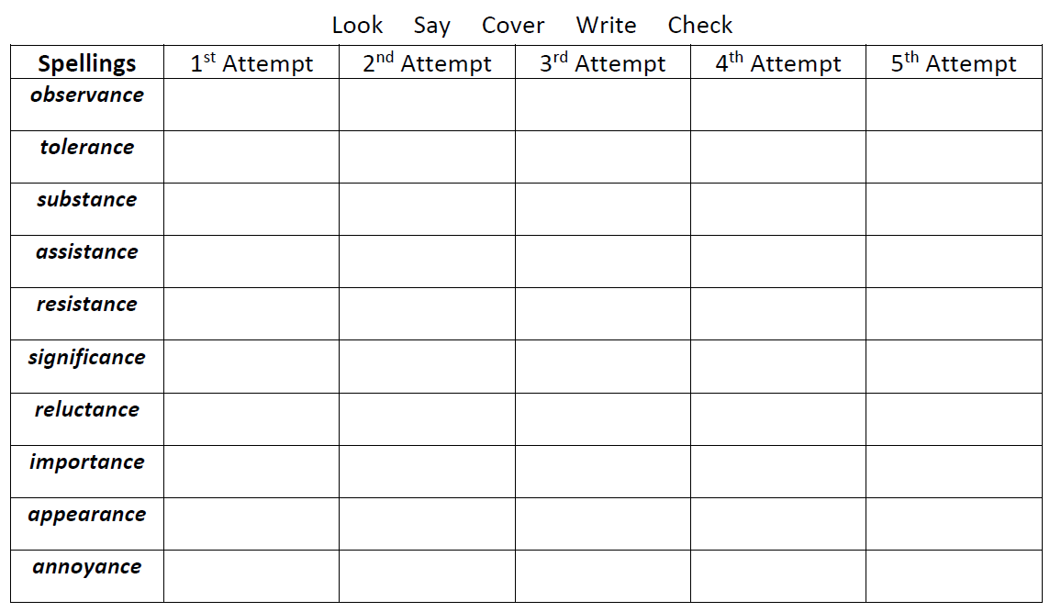

Spellings- Mrs Bird’s group
Spellings
accommodate
accept
accelerate
accident
accurate
accumulate
access

