English 16.9
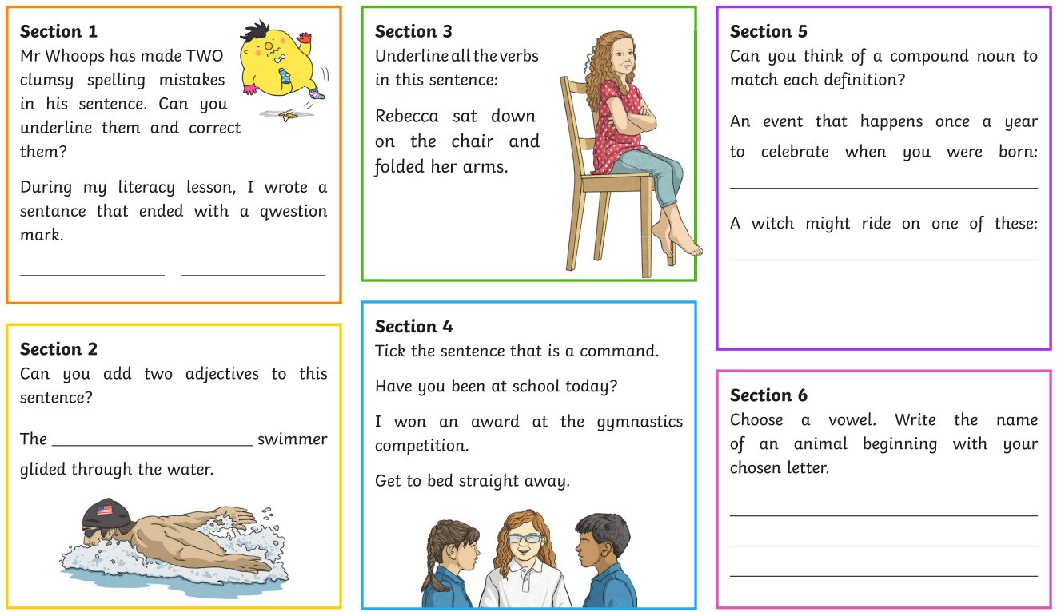
Challenge
Use the following words to write some interesting sentences:
- Gale
- Blizzard
- Vast
- plummeted

