English 9.9.22

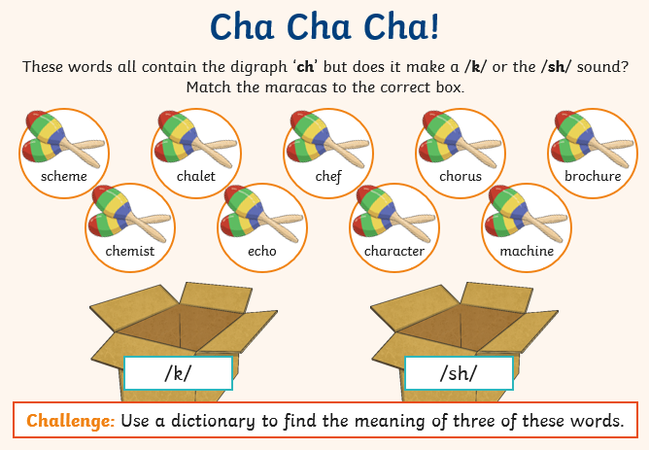

Can you put these words into chronological order?