Maths 7.10
Try the activity below, or if you feel it’s too easy, have a go at the challenge questions.

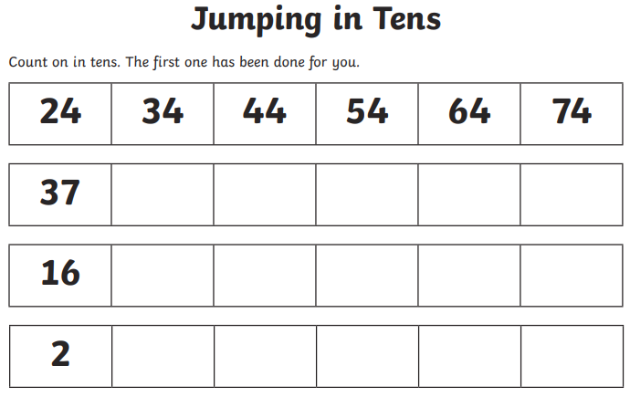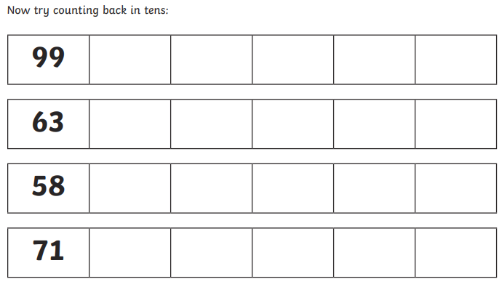

Challenge
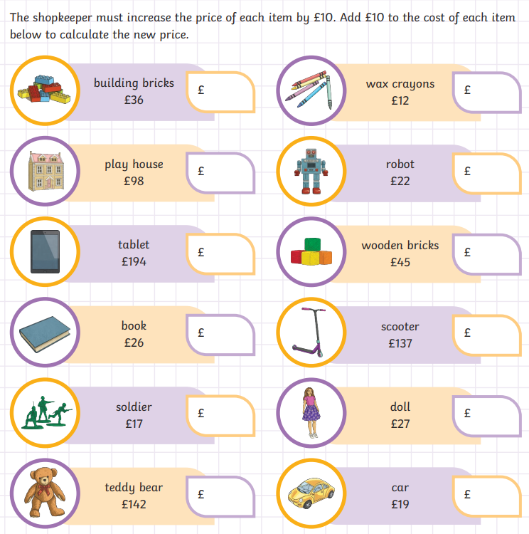

If you found that easy try finding out how much each item would cost if it was £10 less than the original price.

