Maths 18.11.22
Try to learn the 4 times table. If you already know it, try the mastery questions on the second page.
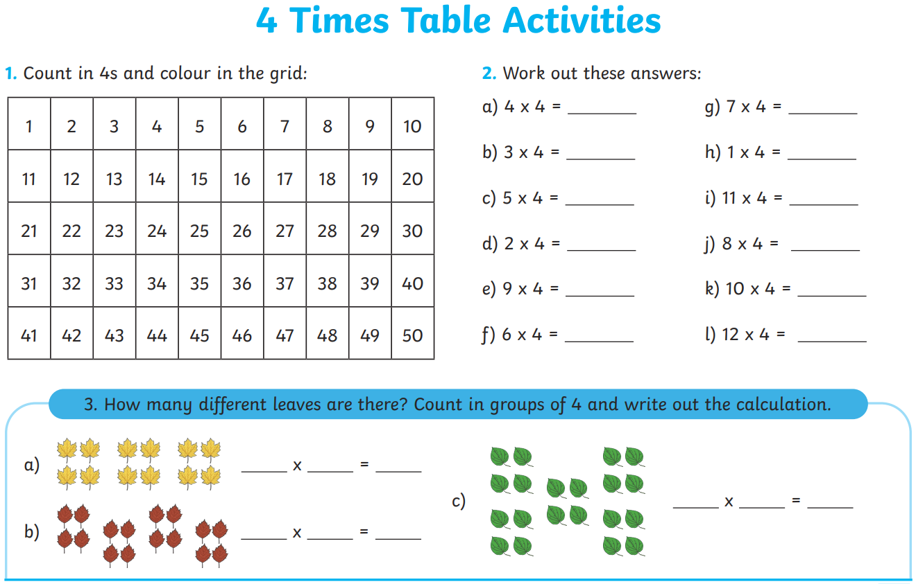
Mastery questions.
