Maths 6.1

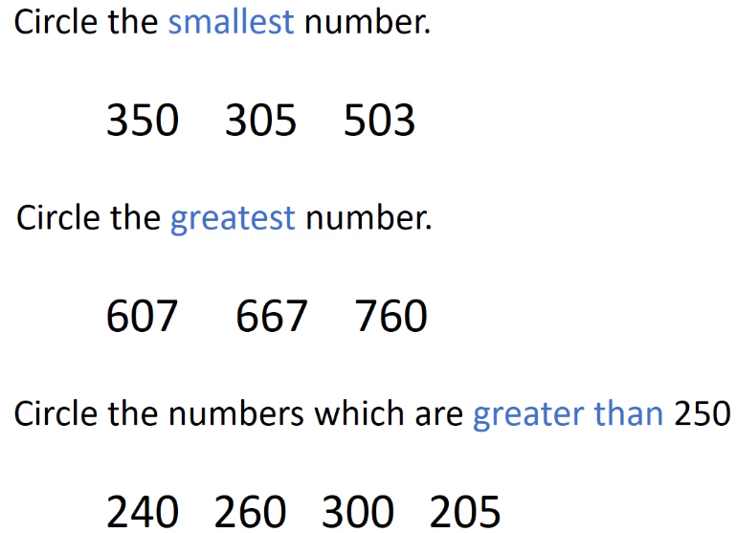

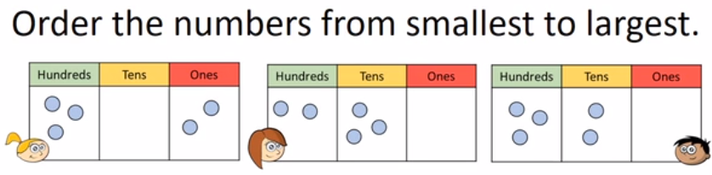

Write their names down on the line starting with the shortest.

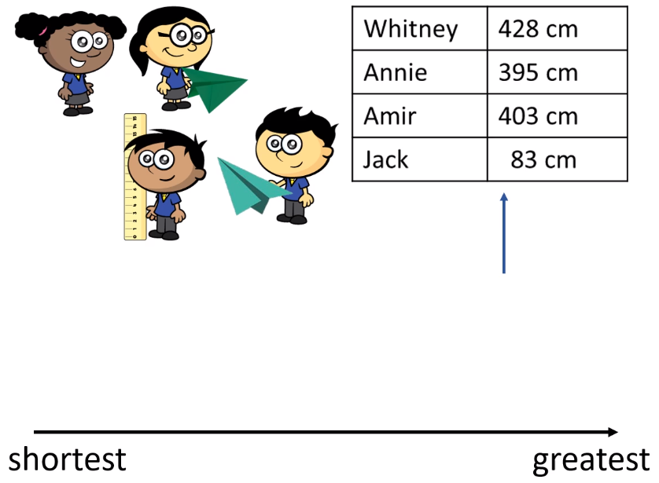

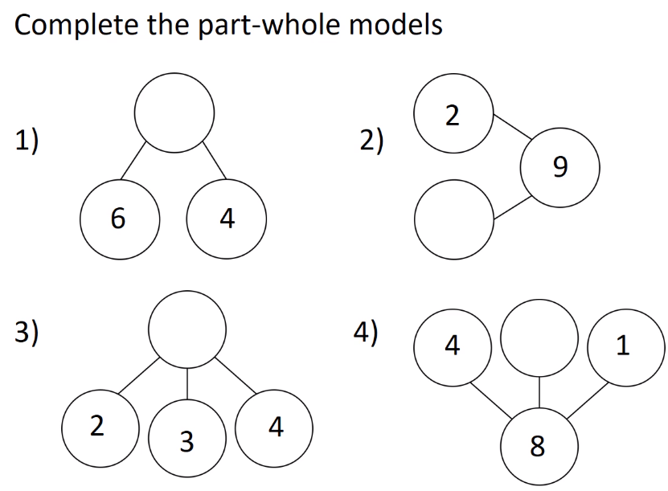

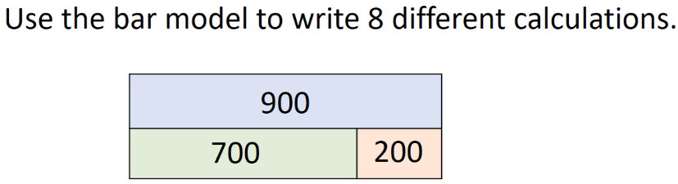

Challenge

