Maths 3.3.23 - choose the correct grid for you a) 2,5,10x tables b) more difficult.
a)
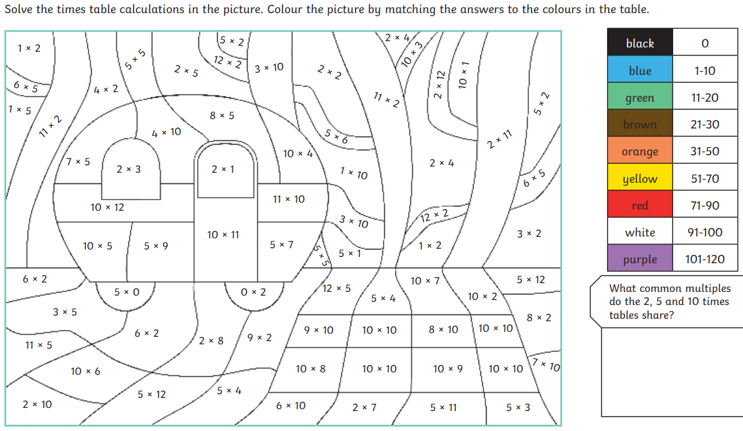

b)
