English 5.5.23
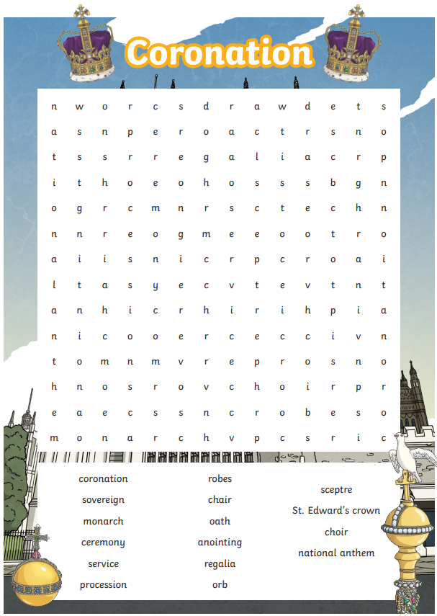

Can you list these words in alphabetical order?

