Maths 12.5

How quickly can you complete these challenges?

A)

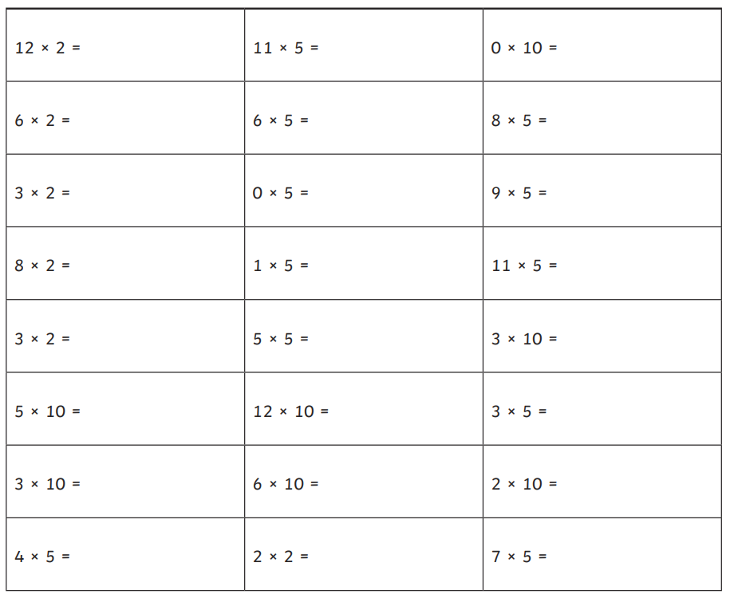

B)

