Charing Primary Forest School

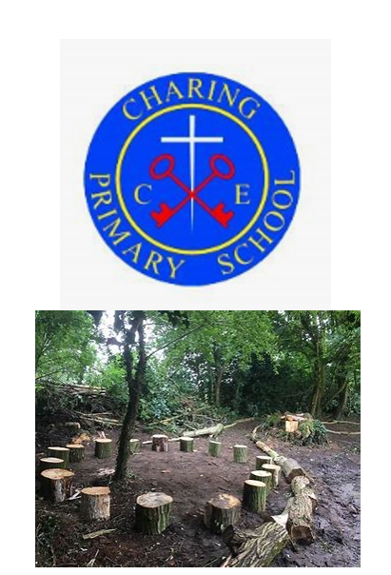

Forest School Handbook
To be read by all Forest School leaders, assistants and helpers.

Handbook Contents
- Introduction to Forest School
- Forest School activities
- Forest School Vision Statement
- Communications
- Contact with parents, children and stakeholders (leaflet)
- Forest School Rules
- Roles and responsibilities of adults and children
- Example of sessions
- Lesson Plans
- Risk Assessments
- All tools
- All activities
- Cooking fire
- Ropes and Cord
- Daily operating procedure/ site safety check
- Map of site
- Environmental Impact Assessment
- Management Plan
- Flora and Fauna List
- Welfare Bag Contents and Kit List
- Safeguarding
- Safeguarding
- Confidentiality
- Child/vulnerable protection
- Data Protection
- DBS
- Disclosure
- Lost or Missing Child
- Staff ratios
- Visiting staff and helpers
- Policies
- Toileting Policy
- Clothing Policy
- Fire Policy
- Food and Drink (Food Hygiene) Policy
- Tree Climbing Policy
- Adverse Weather Policy
- Behaviour Policy
- First Aid Policy
- Hazardous Plants and Fungi Policy
- Equal Opportunities
- Accident and Emergency Plan/ Procedures
- Incident Reporting
- Digital Photo/ Video
- Play
- Personal Protective Equipment
- Fire Management
- Selecting and sitting fire
- Using a fire for cooking
- Fire lighting
- Tools
- Transportation
- Storage
- Maintenance
- Safe usage of each tool
- Appendix
- Incident Log Form
- Forest School Handbook Agreement

1 Introduction to Forest School

‘Forest School is a child-centred inspirational learning process, that offers opportunities for holistic growth through regular sessions. It is a long-term program that supports play, exploration and self-esteem through learner inspired, hands-on experiences in a natural setting’ (Forest School Association). Forest School consists of key features such as:
- Run by Level 3 qualified Forest School Leaders.
- Regular contact with a natural/ woodland environment over a longer period.
- Learning and development is child-centred and where children learn about risk management.
- High adult: child ratio.
- Learners are observed and support is tailored to individual needs.
- Understanding the value of the natural world.
Forest School was first recognised in the UK as an education system in 1993, when a group of nursery nurses from Bridgwater College, Somerset, visited a Forest School in Denmark. Impressed with the outdoor learning system that they had observed, they started their own Forest School with the children who attended the college. They discovered that it had a positive impact on the development and the well-being of the children. The college then went on to develop a BTech in Forest School, teaching it to educators around the country. With the support of the Forestry Commission in Wales, trainers from England and Wales developed the Open College Network (OCN) qualification in Forest School which began in 2003. Since 2003, the training hubs and support for a Forest School education system in the UK have increased. The Forest School Association (FSA) was launched on 7th July 2012 as the governing body for regulation of Forest Schools in the UK. The Forest School Association have provided 6 guiding principles of good practice in Forest School which are listed below.

Principle 1: Forest School is a long-term process of frequent and regular sessions in a woodland or natural environment, rather than a one-off visit. Planning, adaptation, observations and reviewing are integral elements of Forest School.

Principle 2: Forest School takes place in a woodland or natural wooded environment to support the development of a relationship between the learner and the natural world.

Principle 3: Forest School aims to promote the holistic development of all those involved, fostering resilient, confident, independent, and creative learners.

Principle 4: Forest School offers learners the opportunity to take supported risks appropriate to the environment and to themselves.

Principle 5: Forest School is run by qualified Forest School practitioners who continuously maintain and develop their professional practice.

Principle 6: Forest School uses a range of learner-centred processes to create a community for development and learning.

Although Forest School does not form part of the National Curriculum for the education system in the UK, it can be seen as a gateway to teach many aspects of the national curriculum as there are so many elements that can be integrated or linked to the National Curriculum covering KS1 and KS2 learning outcomes and the Early Learning Goals for EYFS. In addition, Forest School develops life skills that children will develop through their developmental stages and into adulthood. Furthermore, children can develop spiritually, valuing themselves and their understanding and place in the world. When children understand the natural world that they live in, they will develop a sense of belonging which in turn will promote a positive well-being. Moreover, the global focus on world climate and ecological concerns only exerts greater emphasis on educating children on the importance of valuing the nature world. It is for these reasons, Independent Forest Schools and Forest School education in schools, are evermore increasing.

Local Forest School practice and networks
- Forest School Association
- Woodland Trust
- EarthCraft
- Step-Out
- Kent Wildlife Trust
- Kent Country Parks
- Bright Sparks Forest School

1.a Forest School Activities
During our forest school journey, we may:
• Make dens and shelters using natural resources and tarp sheets, tent pegs and cord
• Build things
• Create art
• Climb trees
• Use woodland tools
• Prepare and maintain campfires
- Use the Kellie Kettle and Cook (eat and drink)
• Observe and maintain the woodland environment
- Gardening and gardening tools
• Play games
- with sticks, in the mud, stepping on logs and role-play.
• Use ropes
• Tie knots
• Sing and play instruments
• Spend time reflecting and listening.

2. Forest School Vision Statement

At Charing Primary Forest School, we provide users with an enriched natural/ woodland environment to offer each user the opportunity to develop holistically. Users become part of a Forest School community which strives to develop physical and mental well-being. Users can self-direct their learning through play and exploration whilst learning new skills which will support their ongoing development from childhood through to adulthood. Users will support the sustainable future of the Forest School through education, by helping to maintain it, and by respecting and encouraging the wildlife and habitats that it exhibits.

3. Communication
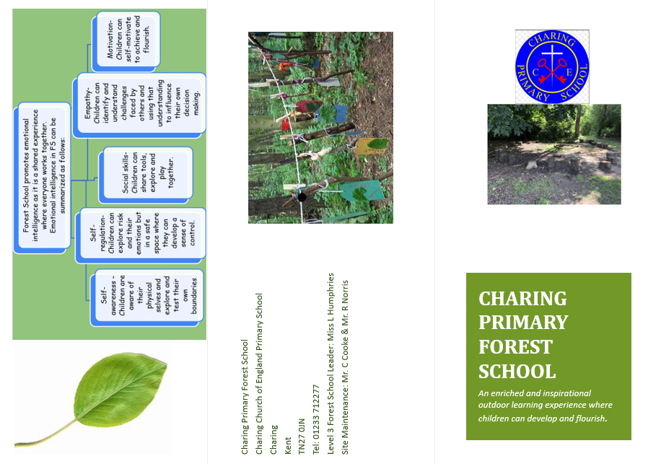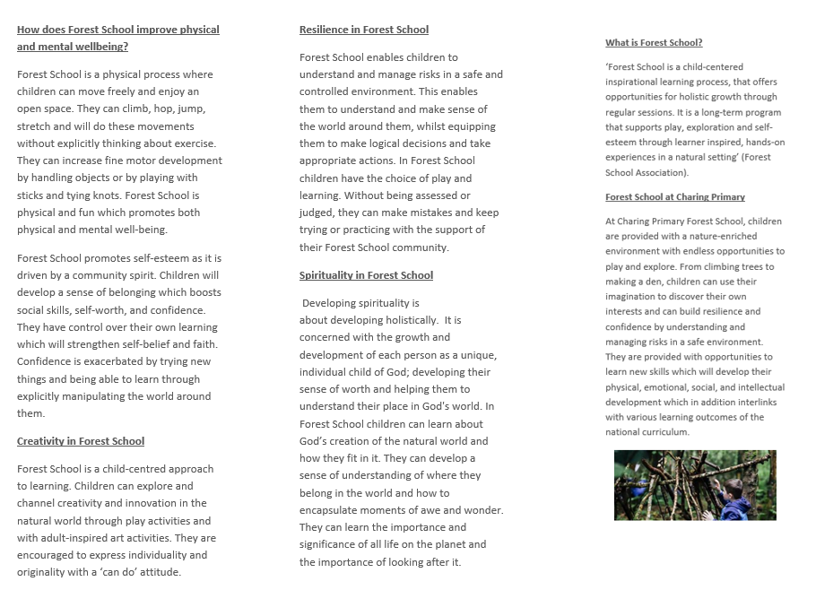

4. Forest School Rules
The 3 main rules underpinning all Forest School rules are:
- Look after yourself.
- Look after each other.
- Look after our Forest School.
Forest School rules:
- Leave no trace.
- No running in Forest School.
- If it’s bigger than you, it takes two.
- Carry and walk forward facing.
- One at each end of branches.
- If climbing trees, no higher than Forest School leader.
- Time out in the log circle (if needed).
- Have fun and enjoy!

5. Roles and responsibilities of adults and children
Forest School leader
The role of the Forest School programme leader will manage, conduct, and maintain the sustainability and ecological impact of the Forest School. The Forest School programme leader will assess the Forest School environment regularly and before every planned session.
For each session, the leader will ensure that a risk assessment is carried out to cover all elements of the session planned. The session should be well thought out and be part of a wider programme informed to deliver on-going development and skills. The resources for the session should be checked, cleaned, and stored away appropriately. The Forest School leader is responsible for promoting a holistic approach to development to ensure that all users can develop to their unique needs.
Support Staff
Support staff have the responsibility of reading the handbook and being familiar with the assessed risks and planned activities for the session that they are attending. They should be familiar with the principles of Forest School and understand how the principles are integrated into Forest School sessions. They will be First Aid trained and will have the responsibility of attending to First Aid incidents in Forest School.
Children
Children have the responsibility to adhere to the Forest School rules and boundaries. They are responsible for ensuring that the Forest School is valued, respected, and maintained.

- Examples of sessions (Six Week Programme- Lesson Plans)

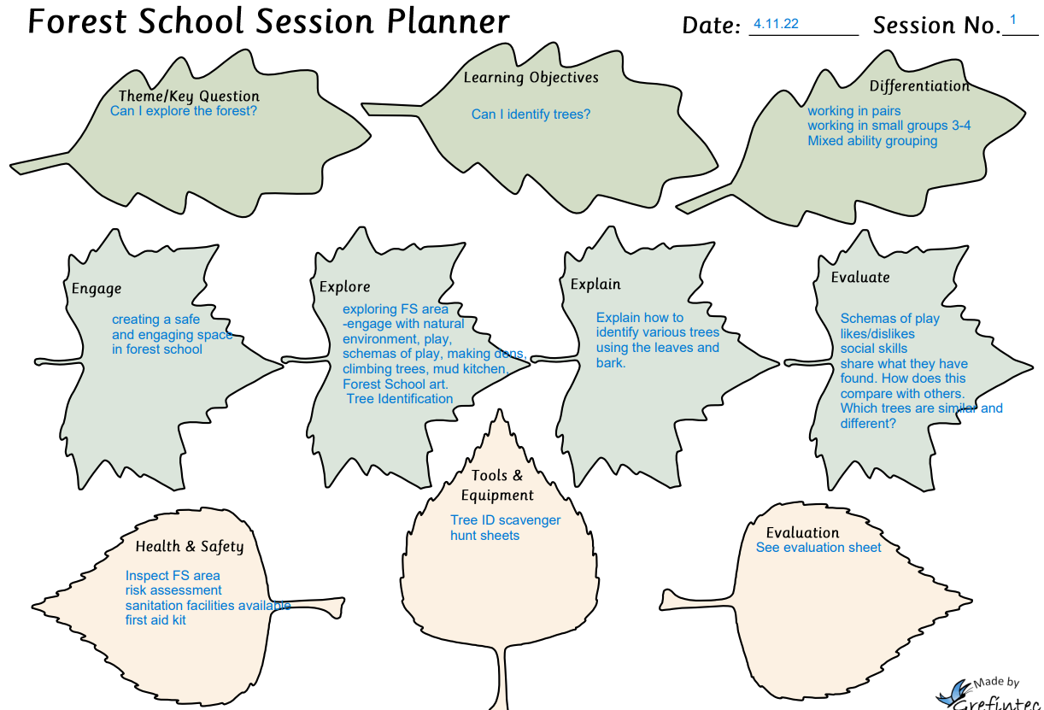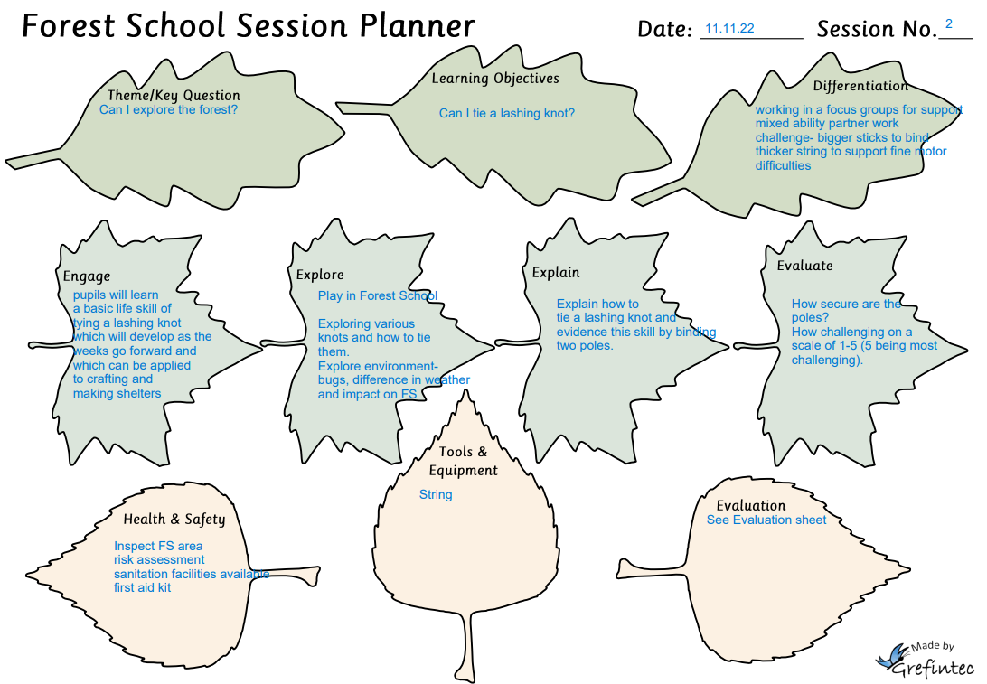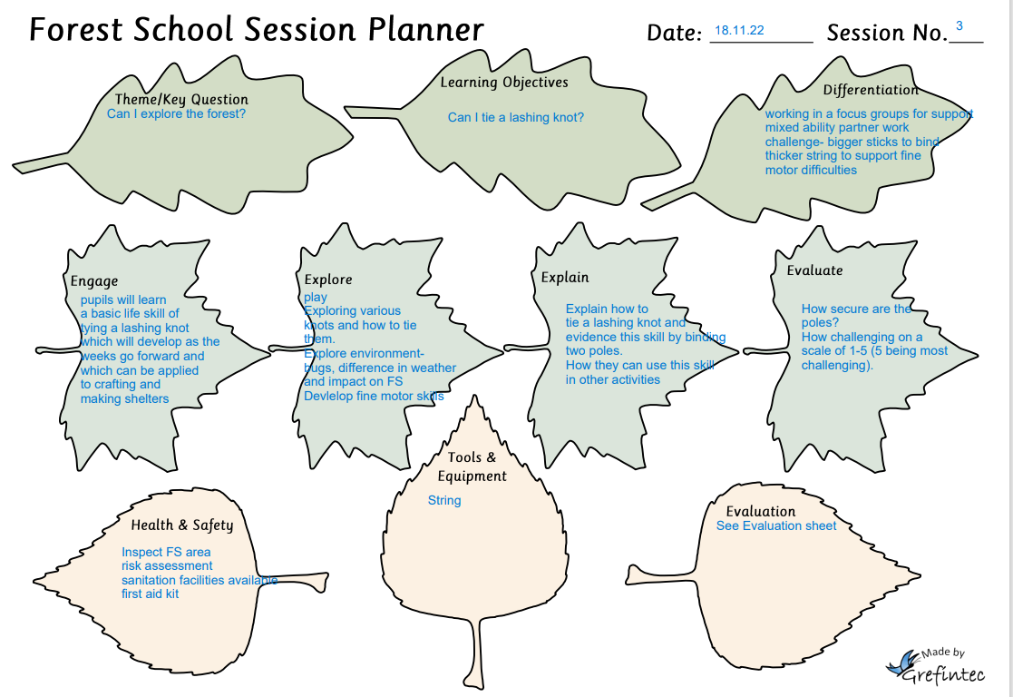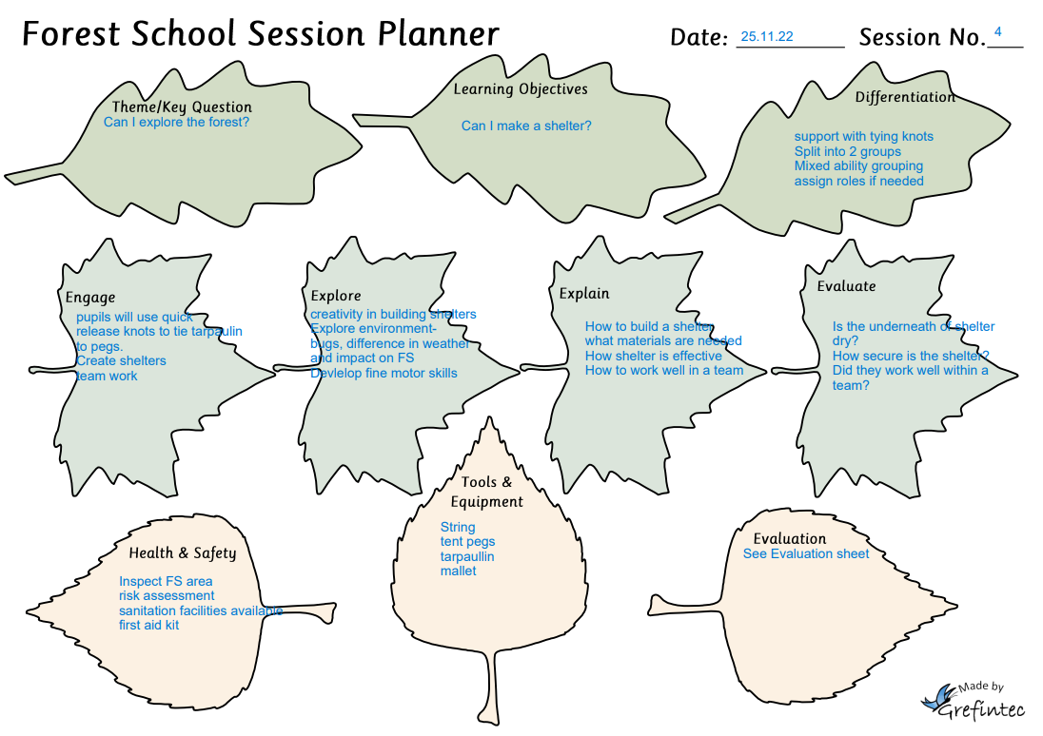
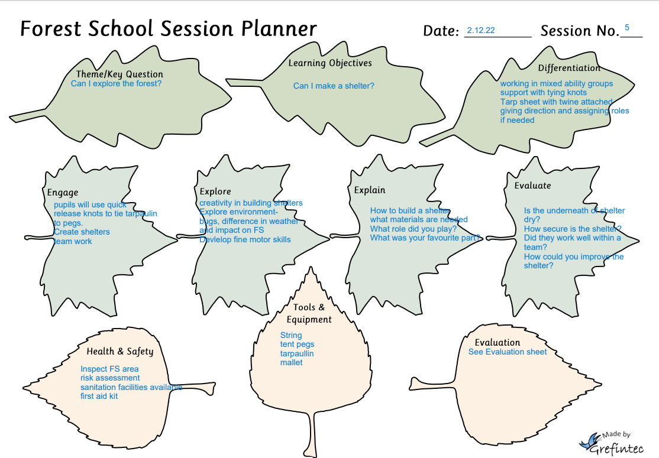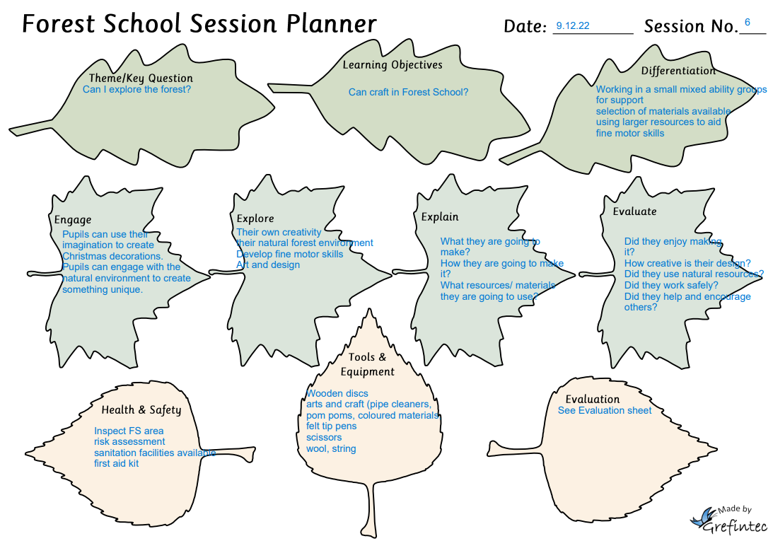

- Risks assessments
7.a All Tools

Forest School Risk Assessment

Assessment carried out by: L. Humphries

Date assessment was carried out: 21.6.23
Using Tools
tool | What are the hazards? | Risk | Risk rating | Action to control risk | Revised risk rating | Who needs to carry out the action? | Risk/ benefit
Palm drill | Incision  infection | bleeds | low | Safety talk about resources and equipment  PPE  Model how to use tool.  Adhere to tool safety sheet | low | FS Leader | - Fine motor skills development  - Survival/ life skill development  - Psychological well-being development
Bill hook | Incision | Bleeding  infection | moderate | Safety talk about resources and equipment  PPE  Use equipment safely.  Adhere to tool safety sheet | low | FS Leader | - Fine motor skills development  - Survival/ life skill development  Psychological well-being development
Bow saw | Cuts | Bleeds  infections | moderate | Expectations and safety talk  PPE  Model how to use.  Adhere to tool safety sheet | low | FS leader | - Fine motor skills development  - Survival/ life skill development  - Psychological well-being development Engaging with nature.  - Development a love and respect for nature/ woodland  Curriculum development
Junior hacksaw | cuts | Bleeds  Infections | low | Expectations and safety talk  PPE  Model how to use.  Adhere to tool safety sheet. | low | FS leader | - Fine motor skills development  - Survival/ life skill development  - Psychological well-being development Engaging with nature.  - Development a love and respect for nature/ woodland  Curriculum development
Vegetable peelers | Cuts  incisions | Bleeding  Infections | Moderate | Expectations and safety talk  PPE  Model how to use.  Adhere to tool safety sheet | low | FS leader | - Fine motor skills development  - Survival/ life skill development  - Psychological well-being development Engaging with nature.  - Development a love and respect for nature/ woodland  Curriculum development
Bradawl | Cuts  Incision | Bleeding  Infections | moderate | Expectations and safety talk  PPE  Model how to use.  Adhere to tool safety sheet | low | FS Leader | - Fine motor skills development  - Survival/ life skill development  - Psychological well-being development Engaging with nature.  - Development a love and respect for nature/ woodland  Curriculum development
scissors | Cuts  Incisions | Bleeding  Infection | low | ‘  Expectations and safety talk  PPE  Model how to use.  Adhere to tool safety sheet.  Child scissors | low | F Leader | - Fine motor skills development  - Survival/ life skill development  - Psychological well-being development Engaging with nature.  - Development a love and respect for nature/ woodland  Curriculum development
Mallet | Bang to the hand | Brusing, swelling | moderate | Expectations  Health and safety talk | low | Forest School leader | - Create and make things.  - Fine motor skill development  - Develop self-confidence.
secateurs | Cuts and incision | Bleeds | moderate | PPE to worn.  Safety talk  Expectation for behaviour set.  Model how to use correctly and safely.  Adult: Child ration 1:1. | low | Forest School leader | Help to maintain natural environment and Forest School.  Fine motor skill development  Development of confidence.
Loppers | Cuts and incision | Bleeds | moderate | PPE to worn.  Safety talk  Expectation for behaviour set.  Model how to use correctly and safely.  Adult: Child ration 1:1 | low | Forest School leader | Help to maintain natural environment and Forest School.  Fine motor skill development  Development of confidence.

7.b All activities

Assessment carried out by: L. Humphries

Date assessment was carried out: 4.11.22
Tree ID

What are the hazards? | Risk rating | Action to control risk | Revised risk rating | Who needs to carry out the action? | Risk benefit
Trip hazard | high | move larger.  Objects that are covered by leaves.  Make everyone aware at the beginning of the lesson.  3 rules – include no running | low | FS leader | - Pupils have space to move around.  - Enjoy the benefits of being outside and the forest environment.  - Develop respect and value nature.  - Develop spirituality
slips | high | Ground is wet- make all aware+ mossy areas.  -3 rules (look after self, others and FS) include no running | Moderate | FS leader | - Pupils have space to move around.  - Enjoy the benefits of being outside and the forest environment.  - Develop respect and value nature.  Develop spirituality
Touching poisonous fungi, berries | Moderate | Search the site-  Safety talk  Fungi identification sheet | low | FS leader | - Pupils have space to move around.  - Enjoy the benefits of being outside and the forest environment.  - Develop respect and value nature.  Develop spirituality
Over hanging branches | moderate | Monitor site and section off areas | low | FS Leader | - Pupils have space to move around.  - Enjoy the benefits of being outside and the forest environment.  - Develop respect and value nature.  Develop spirituality

Building shelters
What are the hazards? | Risk | Risk rating | Action to control risk | Revised risk rating | Who needs to carry out the action? | Risk/ benefit
trips from tent pegs | Injury to bones and muscles, cuts and bruises | low | Safety talk about resources and equipment  Ensure all adults and children are aware of where tent pegs are | low | FS Leader | - Fine motor skills development  - Survival/ life skill development  - Psychological well-being development
Incision from tent pegs | Bleeding  infection | moderate | Safety talk about resources and equipment  Use equipment safely | low | FS Leader | - Fine motor skills development  - Survival/ life skill development  Psychological well-being development
Tangled in tarp sheets/ cords | Strangulation | low | Expectations and safety talk set at beginning of the session | low | FS leader | - Basic life skill  - Increase in self-development and actualisation (Maslow hierarchy of needs)
Wet surfaces and areas/ slips and falls |  | high | Ground is wet- make all aware+ mossy areas.  -3 rules (look after self, others and FS) include no running | Moderate | FS leader | - Engaging with nature  - Development a love and respect for nature/ woodland  Curriculum development
poisonous fungi, berries / touching ingesting |  | Moderate | Search. the site-  Safety talk  Fungi identification sheet | low | FS leader | - Engaging with nature  - Development a love and respect for nature/ woodland  Curriculum development
Over hanging branches |  | moderate | Monitor site and section off areas | low | FS Leader | - Engaging with nature  - Development a love and respect for nature/ woodland  Curriculum development
Moving and handling logs and branches/ dropping them on feet |  | moderate | ‘If it’s bigger than you, it takes two’  Carry with two hands | low | F Leader | - Engaging with nature  - Development a love and respect for nature/ woodland  Curriculum development

Forest School Kellie Kettle/ fire/ cooking
What are the hazards? | Risk | Risk rating | Action to control risk | Revised risk rating | Who needs to carry out the action? | Risk benefit
Injury from cutting and preparing wood | Bleeding  infection | high | To model how to use tool safely.  Set safety rules and expectations at the beginning of the session.  Use correct PPE.  Adult to pupil ratio 1:2 | low | FS leader | - Physical skill development  - Survival skill development  - Well-being development  - Teamwork
Burns from direct fire or heat | burns | high | Set safety rules and expectations at the beginning of the session.  Use correct PPE.  Do not exceed barrier around the fire.  Ensure fire is put out safely and efficiently.  Adult to pupil ratio 1:3 | Moderate | FS leader | - Physical skill development  - Survival skill development  - Well-being development  - Teamwork
Burns from steam | scalds | Moderate | Set safety rules and expectations at the beginning of the session.  Use correct PPE.  Do not exceed barrier around the fire.  Ensure fire is put out safely and efficiently.  Adult to pupil ratio 1:3  Pupils do not touch the kellie kettle | low | FS leader | - Physical skill development  - Survival skill development  - Well-being development  Teamwork
choking | Asphyxiation | moderate | Safety talk at the beginning of session  expectations  Safe eating habits | low | FS Leader | - Survival skill development  - Well-being development
Burns from food | Burns to mouth and body | high | Safety talk at the beginning of session  Expectations  PPE to be worn.  Allow time for food to cool. | moderate | FS Leader | - Survival skill development  - Well-being development
Smoke inhalation | Frustrating asthma sufferers  Chest infection | high | Medical box and first aid  Asthma pumps for specific pupil  Sit on the outer circle of the fire.  Sit away from wind direction.  Adult ratio for fire barrier 1:3 | low | FS Leader | - Survival skill development  - Well-being development

Working with ropes and cord
What are the hazards? | Risk | Risk rating | Action to control risk | Revised risk rating | Who needs to carry out the action? | Risk/ benefit
Trips from ropes/ cords | Injury to bones and muscles, cuts and bruises | low | Safety talk about resources and equipment  Ensure all adults and children are aware of where cords and ropes are. | low | FS Leader | - Fine motor skills development  - Survival/ life skill development  - Psychological well-being development
Tangled in ropes and cord | Injury  Strangulation | moderate | Safety talk about resources and equipment  Ensure all adults and children are aware of where cords and ropes are. | low | FS Leader | - Fine motor skills development  - Survival/ life skill development  Psychological well-being development
Larger logs and branches/ trips and falls |  | high | move larger  objects that are covered by leaves.  Make everyone aware at the beginning of the lesson.  3 rules – include no running | low | FS leader | - Engaging with nature  - Development a love and respect for nature/ woodland  - Curriculum
Wet surfaces and areas/ slips and falls |  | high | Ground is wet- make all aware+ mossy areas.  -3 rules (look after self, others and FS) include no running | Moderate | FS leader
poisonous fungi, berries / touching ingesting |  | Moderate | Search the site-  Safety talk  Fungi identification sheet | low | FS leader
Over hanging branches |  | moderate | Monitor site and section off areas | low | FS Leader
Moving and handling logs and branches/ dropping them on feet |  | moderate | ‘If it’s bigger than you, it takes two’.  Carry with two hands | low | F Leader

- Daily Operating Procedure/ site safety check

- Walk around site and observe and assess conditions of site (impact risk assessment), low-hanging branches and weather conditions etc.
- Check for unsanitary conditions, (dead animals, faeces, or rubbish)
- Check resources for sessions and prepare for session.
- After sessions – make sure resources are stored away clean and dry. All resources and tools locked away.

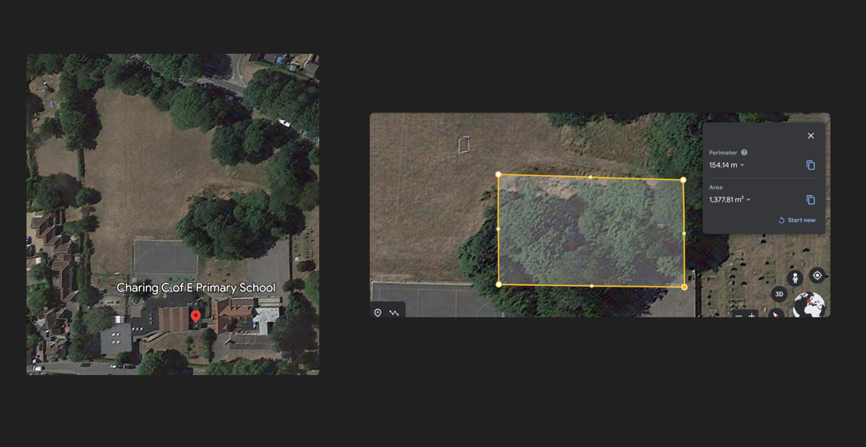
- Map of Site

- Environmental Impact Assessment
Activity | Ground Layer | Field Layer | Shrub Layer | Canopy Layer | Deadwood | Nesting Birds | Pathways | Other Habitats
Fire | x |  |  | x | x | x |  | x
Den Building | x | x | x |  | x |  | x | x
Tood Based Activities | x |  |  |  | x
Exploring | x | x | x |  | x |  | x | X
Environmental Art | x | x |  |  | x |  | x | x
Gardening and pruning | x | x | x |  |  |  |  | X
Obstacle courses | X |  |  |  | x |  | x | x
Shelters | x | x | x |  | x |  |  | X
Making Animal habitats | X | x | x |  | x |  |  | x
Rope Swing | x | x | x |  |  |  |  | X
Rope Ladder | X | x | x |  |  |  |  | x
Bug hunting | x | x | x |  | x |  | x | X
Tree, plant and fungi ID | x | x | x |  |  |  | x | x

- Management Plan
Charing Primary Forest School
Name: Charing Primary Forest School | Location: Charing Primary School, School Rd, Charing, Kent, TN270JN | Owner: Charing Primary School
General Description:
Charing Primary Forest School is in Charing Church of England Primary School, which is in Charing, Kent. The school was established in 1873 and has developed its school site to include the primary school main buildings, 3 playground areas, a large playing field and a small woodland Forest School area with a pond. The Forest School area is maintained by the Forest School Leader and an onsite maintenance team. The Forest is accessed through passing the playground at the front of the Forest School and through the playing field at the back of the Forest School. The front entrance of the Forest School consists of a vehicular access point which enables vehicles to pass through and onto the school playing field.
The Forest School area has been used for outdoor learning and play activities for many of years where children have made use of the small woodland pond area. The Forest School has been set up since September 2022 where it has been used to make up part of the school’s curriculum for children in EYFS, KS1 and KS2.
The Forest School area also consists of two storage sheds, both of which are code locked. In addition, the pond area adjoining to the main Forest School area is fenced and gated. At the back of the Forest School area leading onto the school playing field is a small grassland area surrounded and enclosed by hedging and trees.

Forest School Description:
Charing Primary Forest School is located within the school’s grounds towards the far right-hand side of the school and behind one of the school’s playground.
The area is approximately, 24m x 46m. Elder, ash and field maple trees are some of the trees present in the Forest School area. There is predominantly, holly, brambles, and nettles amongst the trees towards the back of the Forest School. The Forest school area consists of a log circle which surrounds the fire pit, where users come together for gathering, discussion and reflection.
There are no known nesting birds on this site, but this is assessed and managed in the three-year sustainable management plan. A variety of woodland animals can be found within the site such as small rodents, different species of birds, foxes, frogs, and squirrels.
There are no archaeological considerations or tree protection orders on the site.

Long Term Vision:
The Forest School will be used several days of the week in term-time only for Forest School provision. Forest School provision will be carried out in the Autumn and Spring/ Summer Terms. To protect habitats and fauna, some Forest School sessions will be carried out within natural areas around the school site and outside of the Forest School area and this will be in the Spring terms. In addition, the area will be undisturbed through the six- week summer holiday period. Many areas within the Forest School will remain untouched/ undisturbed, such as the thick boundary hedging made up of brambles, nettles and holly which surround the Forest School and provide habitats for many animal species.
The Forest School site will expand towards the back of the Forest School which will include planting new trees. The front of the Forest School will be bounded by natural hedging providing a natural habitat for wildlife and inclusion for Forest School sessions and Forest School life.

Sustainable Forest School management Plan
Factor | Location | Current Situation | Target Situation | Preventative  Measures | Monitoring | Method of management | Timescale
pathways | From access points and around brambles | Bramble and nettles either side | To keep access available | Ensure activities are moved around the site. | Review regularly  Throughout seasons. Monitor growth. | Keep pathway clear | Year 1 - 3  Keep monitoring.  Year 3- Review
Deadwood | Throughout site | None present on trees.  Branches on site | Deadwood to remain untouched | Monitor  Education for users on the significance of deadwood for biodiversity | Regular monitoring | To remove safely any dangerous deadwood to ground level if applicable.  To safely input deadwood | Year 1 – monitor  Year 2- input deadwood  Year 3- continue monitoring
Brambles | Either side of pathways  Significant low-level patches | Does not overhang onto pathways | To maintain at low level and off pathways | To regular assess and maintain. | Regular observations. | Education of users about nature and living flora. | Year 1- 3 Education of users and monitoring and maintaining.
Ground Layer | Throughout | Partial cement  2 x large sleepers  Leaf litter, wood shavings,  Various pits filled with sand in the log circle | To maintain ground layer to its natural state. | Rotation of activities.  Education of users for natural environment.  No manmade materials left on site.  Not dig the mud in the log circle. | Regular monitoring.  Observe changes.  Take frequent photographs of site. | Education of users.  No manmade materials rule.  Alert and discard if found on site.  No digging the mud in the log circle.  Return the log circle back to a natural state.  Input of soil and grass seeds. | Year 1- Monitor  Education of users.  Fill log circle with soil and maintain.  Year 2  Monitor  Rotate activities.  Alternative log circle  Year 3-  Monitor &  Maintain
Trees | Various across the site | Common lime and Edler with an understory of holly. Sycamore and field maple.  (No TPOs) | All trees to be maintained in natural state. | No live flora is used for activities.  Education of users about caring for the trees especially new saplings.  Education of users of how to be carefully and minimise damage when climbing trees.  No fires allowed where canopy is present. | Regular observation with users during sessions. | Education of users about nature and living flora.  Communication with onsite maintenance if trees become damaged and/or unsafe. | Year 1- education of users and monitoring.  Plant hedgerow along the front of the forest school.  Year 2- education of users and monitoring  Plant new saplings towards the back of the forest school.  Education of users and monitoring.
Nesting birds | N/A | Although no nest on immediate site, there are in the trees surrounding the forest school | To ensure are undisturbed | Education of users.  Observe and monitor regularly. No forest school (disturbance in August and February). No fires near nesting birds. | Regular observations, photos, and recordings during sessions. | With users, record in sessions. | Year 1- observe throughout the year regularly.  Year 2- 3  Continue to regularly observe and monitor. Education of users.
Other Wildlife | Throughout site | Various species, in trees, ground level, branches | Maintain existing habitats. | Educate users on habitats.  No pesticides or fertilizers | Observe and review regularly with users.  Take photos.  Record what has been found | To observe and record with the intention of maintaining habitats | Year 1- observe and records habitats.  Year 2-  Introduce animal habitats for species found.  Year 3 – continue monitoring.

Summary
The ecological impact of running the Forest School at this site has been assessed and the main areas of management have been identified:
- It is significantly important for Forest School users to be educated on the natural environment developing their understanding and value of the natural world and its habitats. Users should be educated on the fauna and flora on the site as well as the existing habitats to protect animals and wildlife and potential habitats to encourage wildlife.
- The Forest School ground, field and shrub layers need to regularly monitor to its natural state and maintained around pathways. Forest School activities should be rotated around the site and make use of surrounding areas to protect the environment and allow it to recover to its natural state.
- The Forest School has a log circle which consists of an open canopy which is where a fire is permitted. No fires are to be permitted under a dense canopy.
- To develop the Forest School and encourage animals and wildlife, the Forest School will expand such as planting new saplings and creating a natural hedgerow.

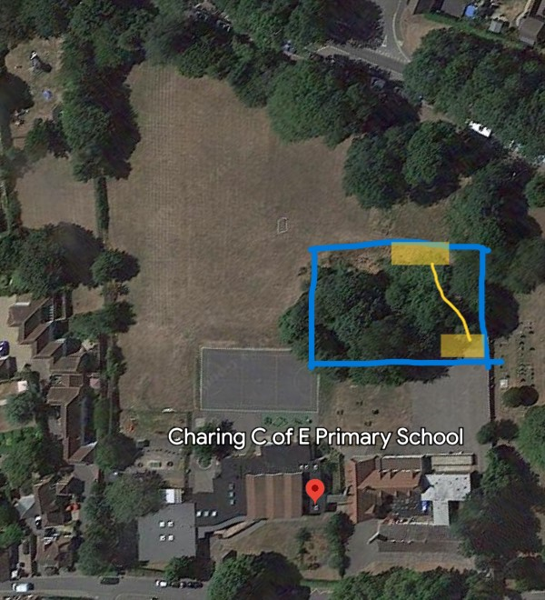
Key
X = Forest School site boundary
X = Access points and pathways (vehicle access and vehicle pathway onto the school field).

- Flora and Fauna List

Flora | Fauna
Red Maple Tree  Laurel Tree  Horse Chestnut Tree  Ash Tree  Elder Tree  Spruce Conifer Tree  Crab Apple  Holly  Brambles  Nettles | Range of common birds  - Robins  - Starlings  - Magpies  - Bluetits  - Woodpigeons  - Sparrows  - Finches  Frogs  Hedgehogs  Mice  Squirrels  Foxes  Worms  Insects and Bugs  - Spiders  - Ants  - Beetles  - Slugs  - Snails  - Woodlice  - Butterflies  - Bees and wasps

- Welfare Bag Contents and Kit List

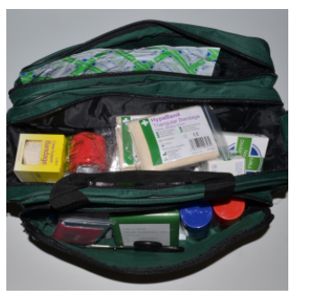
Kit contents:
- Kit bag
- Gloves – powder and latex-free
- Resuscitation pocket mask
- Pocket mask belt bag
- Bandages
  - Conforming 2.5cm x 3m
  - Conforming 7.5cm x 3m
  - Crepe – 5cm x 4.5m
  - Elastic adhesive 2.5cm x 4.5m
  - Tubular size 01 (with applicator)
  - Triangular –
- Dressings
  - Adhesive wound 10 x 8cm
  - Finger 3.5 x 3.5cm
  - Medium (12 x 12cm) wound
  - Large (18 x 18cm) wound
- Saline irrigation pods
- Scissors – tough cut shears
- Tweezers
- Saline wipes
- Plasters (fabric)
- Plasters (blister shield)
- Micropore tape 1.25cm x 3m
- Zinc Oxide tape
- Burn dressing 10cm x 10cm
- Foil Blanket
- Splint (mouldable small)
- Splint (mouldable large)
- Vomit and Urinal bag
- Safeguarding and Child Protection
It is the responsibility of all staff and volunteers to safeguard pupils by ensuring that they have knowledge of and adhere to Charing Church of England Primary School’s Safeguarding and Child Protection Policy. Where there are specific risks, a separate assessment will be carried and shared with staff and volunteers. See school Child Protection Policy for Charing Church of England Primary School in addition:
Aquila child protection and safeguarding 22-23
At Charing Primary School, leaders, support staff, visiting staff and helpers should aim to:
- Ensure that the welfare of children in priority throughout their time in Forest School.
- Provide an environment, where children feel safe, secure, valued, and respected.
- Provide support and guidance with a genuine and sincere approach enabling children to develop confidence to voice when they are in difficulty.
- Use Forest School activities to increase self-awareness, self-esteem, assertiveness, and decision making, to encourage confidence in managing their own protection.
- Monitor children who are particularly ‘vulnerable’ and adhere to a separate risk assessment if it needed.
Disclosure
Appropriate steps will be taken where concerns arise regarding the safety of a participant. Concerns will be reported to a designated safeguarding person and disclosures will be responded to sensitively and appropriately, in line with current best practice.
Lost or Missing Child
Should a child be found to be missing the following procedure is carried out:
• All children are called back to the ‘Log Circle’ using a countdown from 10 and a headcount.
• If a child is missing, children are calmly asked if they have seen the child, where and when they last saw them. One adult will look around the Forest School site vigorously; call out child’s name, ask them to call out to you.
• If child has gone off the Forest School site, one adult will stay with the group and one adult with look around the surrounding school site. A member of SLT will be informed.
- Charing Church of England Primary School ‘lost or missing child’ policy will be followed.

Staff Ratios
Adult: Child ratios will alter and will be assessed based on
- the age of the children
- special education needs
- varying levels of risk in activities planned.
The Adult: Child ratios in years 1- 2 are 1:10 and in years 3- 6 are 1:15.
Specific activities that require higher level of risk will be either arranged in advance where additional support staff can be present or will be delivered in smaller groups within the Forest School session.
- fire/ Kellie Kettle/ cooking- Adult: Child ratio = 1:1 (Years 1- 4) and 1:3 (years 5-6)
small hand tools (palm drill, bradawl, vegetable peelers)- Adult: Child ratio = 1: 3 (years 1- 2) and 1: 5 (years 3-6)
- mallet- Adult: Child ratio = 1:1
- loppers- Adult: Child ratio = 1:1 (all year groups)
- bill Hook- Adult: Child ratio = 1:1 (All year groups)
- bow Saw- Adult: Child ratio = 1:1 (All year groups)
- secateurs- Adult: Child ration = 1:1 (All year groups)

Visiting Staff and Helpers
All visiting staff and helpers will:
- be DBS checked and meet conditions set out in Safeguarding and Child Protection Policy.
- read and sign the Forest School Handbook.
- Be directed by the Forest School Leader.

- Policies
Toileting Policy
- Children are to be encouraged to go to the toilet before the session begins.
- If children need the toilet during the session, they are permitted to use the playground toilets which are located near and within sight of the Forest School.
- Forest School leader or support staff will watch the child to and from the toilet from the entrance of the Forest School.
- No more than 2 children at a time to leave the Forest School to use the toilet.
- For children in years 1 and 2, a member of staff may assist a child to and from the toilet. This will be assessed based on individual needs. If adult: child ratios in Forest School are affected as a result, all children will return to the log circle until adult: child ratios are adequately met.

Clothing Policy
It is not the Forest School leader’s responsibility to ensure that children arrive at school with appropriate clothing and footwear. Guidance for Forest School clothing and footwear and for class sessions are available in the Forest School handbook. Children should expect to get muddy and wet and should wear clothes and footwear which are suitable for all weather conditions with the expectation of getting muddy and possibly ruined.
A coat is essential in Forest School. Forest School is predominantly shaded and so can become cold. If a child gets cold during their session, this will impact on their learning and development during that session. Children can take their coats off and leave them in a designated area along with their water bottles, should they need to. In addition, children are advised to wear wellie boots/ weather- proof in all weathers. If the Forest School leader decides that a child does not have the adequate clothing/ footwear and consequently, the health and safety of the child is at significant risk, the child may be excluded from the Forest School session.
Summer/ warm weather
- Lightweight trousers/ joggers/ leggings
- Lightweight long-sleeved top
- Sturdy shoes or trainers or boots
- Layers are recommended.
Winter/ colder weather
- Trousers/ joggers
- Long-sleeved tops, jumpers
- Sturdy and weather- proof shoes/ boots
- Warm winter coat
- Hat and gloves
- Waterproofs
- Additional layers (trousers and tops) if the weather is particularly cold.

Fire Policy
All Forest School practitioners and visiting and helping staff should have knowledge and adhere to Charing Church of England Primary School’s Fire Policy and Procedures.
At Charing Primary Forest School, the fire policy is to:
- Provide a suitable and safe evacuation procedure (conforming to Charing church of England Primary School’s Fire policy.
- Communicate this procedure with all staff in Forest School
- Carry out the procedure if necessary.
- Test, review and revise the fire policy and procedure.

Fire procedure at Charing Primary Forest School:
- Forest School practitioner instructs evacuation of site to the assembly point towards the rear of the Forest School, at the back of the school playing field.
- Before leaving the site, support staff to check all areas (including toilets).
- At the assembly point, a fire register is taken (School Fire policy and procedure will come into effect).
- In the event, that a fire should occur unexpectedly or become out of control within the forest school, the Forest School leader will evacuate children from either the front or back, access point (assessment based on the severity and location of the fire) and to the assembly point located at the far end of the school’s playing field. Steps 2 and 3 will commence. SLT and School are alerted.
- Forest School leader will assess severity of fire and control if it is possible.
- If a fire is out of control, Forest School leader will contact emergency services.
- Emergency services will be met and guided to the nearest accessible point.

Food and Drink Policy (Food Hygiene)
Forest School leaders, staff and visiting staff should have knowledge of and adhere to the school’s Food and Drink Policy and/or Healthy Eating policy.
It is the class teacher’s responsibility to provide the Forest School leader and the Forest School support staff with individual dietary needs such as dietary rules of religious groups, vegetarian or vegan or allergies. This information should be provided to the Forest School leader in advance of sessions.
Food and Drink Procedure
- It is fundamental that children’s basic needs are met (Maslow’s pyramid of Hierarchical Needs). Children must obtain physical needs of warmth, food and drink.
- Children will have access to drinking water throughout the session. Forest School staff will inform children that they can ask or have a drink at any time.
- Children will be given appropriate utensils for age/ developmental stage.
- Sanitation/ hand washing facilities will be available every session.

Tree Climbing Policy
Tree Climbing is permitted in two trees on the Forest School site. A risk assessment is carried out before every session. This considers the conditions that may affect the safety of children for activities such as tree climbing, such as weather and wet/ slippery surfaces. If tree climbing is permitted, the following rules apply:
- Climb no higher than Forest School practitioner’s height.
- Only two climbing at one time.
- Minimal damage to the tree.
- Turn taking.
Adverse Weather Policy
Children are encouraged to go out into Forest School in both warm and cold weathers. It is important that children are equipped for their Forest School session by adhering to the Forest School Clothing Policy. Forest School will may not take place in conditions which the Forest School leader believes will pose a risk to health and safety.
- If there is adverse weather on the day of a Forest School session, the Forest School leader will decide if it is safe to go out on site.
- If the situation is assessed as being a risk to health and safety, the session will be cancelled.

Behaviour Policy
Forest School practitioners are expected to adhere to Charing Church of England’s Behaviour Policy. Children’s behaviour needs to be monitored and always managed.
Behaviour Procedure
- The type of behaviour that is expected from children during Forest School activities should be explained and modelled by the Forest School leader.
- If a behavioural problem persists, the disruptive individual will be removed from the situation temporarily. Due to the nature of Forest School activities, unsuitable behaviour will not be tolerated and could lead to premature ending of a session.
- Class teachers should inform the Forest School leader of any behavioural issues or specific protocols to manage individual needs. This will allow the Forest School leader to risk assess an activity for a specific child.

First Aid Policy
Forest School leaders, support staff and helpers should have knowledge of and adhere to Charing church of England’s First Aid Policy.
In accordance with Health and Safety (First Aid Regulations 1981- Forest School leaders and support staff are required to provide adequate and appropriate assistance and equipment to enable first aid to be carried out should a child/ person become injured or ill. A First Aid/ Welfare Kit will be carried to all Forest School sessions. In addition, a separate bag will be taken which will carry first aid items for the specific health concerns of individuals in that class.
Please see Welfare Bag Contents and Kit List (Section 13).
Forest school practitioners will report of any work-related death or injury lasting over three days, diseases or dangerous occurrence that may not have resulted in reportable injury, but which clearly could have near misses.
OFSTED should be notified of any significant injuries within 14 days.
First aid will be given in school by named first aiders.
Injuries and accidents will be recorded in the Forest School Log.
Hazardous Plants and Fungi Policy
It is the Forest School leader’s responsibility to understand the types of plants and fungi within the Forest School site. Regular monitoring of flora and fauna within the site will identify hazardous plants and fungi. As part of the risk assessment, a sweep of the site will include checking for hazardous plants and fungi. There are some common hazardous plants located on site, such as, stinging nettles, brambles, berries, and horse chestnuts. In addition, various types of fungi have been observed throughout the site.
Hazardous Plants and Fungi Procedure
- Identify any hazardous plants and point them out to the group so that all members are aware of the dangers.
- Forest school leader will identify common poisonous plants and fungi to children teach them how to identify them and to avoid them.
- Document additional hazardous plants and fungi into Forest School Handbook.

Equal Opportunities
Forest School leaders, support staff and helpers should have knowledge of and adhere to Charing Church of England’s Equal Opportunities Policy.
At Charing Primary Forest School, all those involved with Forest School activities have the right to be treated equally and with respect. All users of the Forest School should have access to a safe and secure environment. All users should have access to Forest School activities and should feel that their contributions are valued and appreciated. All Forest School activities should be available to everyone, regardless of their gender, beliefs, mental or physical health, religion, age, sexuality or ethnicity.

Accident and Emergency Plan Procedures and incident reporting
- The Forest School leader should have a first aid kit, a burns kit and a fire blanket on site. The Forest School leader and support staff should be trained to treat minor accidents/ incidents.
- If a child or member of staff has an accident, they should receive treatment from the first aid qualified member of staff.
- The Forest School leader is responsible for deciding if somebody requires hospitalisation.
- All minor first aid treatment should be recorded using a first aid log form. One copy needs to be given to the school’s office for filing, one copy should be put into the Forest School log and one copy should be given to the casualty.
- Near misses should be logged and all staff should be informed.

Emergency Procedure
- If a major accident/ incident occurs resulting in major injury or illness, the Forest School leader will carry out first aid and the emergency services will be called.
- SLT will be alerted.
- Children will be escorted off site by support staff.
- Emergency Services will be directed on site.
- All major accidents/ incidents will be reported and logged.

Digital photos/ videos
The Forest School leaders, support staff and helper should have knowledge of and adhere to Charing Church of England’s GDPR Policies. It is the responsibility of the Forest School leader to protect and safeguard children. Personal data including photographs of children may be taken for a range of reasons but will coincide with school policy.

Play
Forest School is a child-centred learning environment where children can have access to learning through play. The Forest School leader should plan and implement sessions which encourage play by allowing children time, space and a selection of activities.

Personal Protective Equipment
Personal Protective Equipment will be supplied by the Forest School should there be a risk to health and safety that cannot be adequately controlled in other ways. Risk assessments will inform what PPE is needed.

Fire Management Policy
- Fire safety and management facilities and equipment will be on site and will be used as necessary.
- Fires are to be prepared and lit by or under supervision of the Forest School leader.
- Fires are located under an open canopy.
- Fires will have a surrounding barrier of logs with a distance of at least 0.5 metres from the barrier to the fire.
- Risks assessments will be carried out and hazards and potential risks will be identified before the session begins.
- SLT and site maintenance will be informed prior to session.
- Children will be briefed and informed of expectations and procedures before going onto site.
- Children will walk around the outside of the log circle and will have a designated log (seat).
- Children will only come to the inner fire barrier if they have permission from the Forest School leader.
- Adhere to the Fire policy if a fire becomes out of control.
- Fire will not be left unattended.
- Fires will be extinguished by thoroughly dousing with water and will remain barriered off until the embers have completely cooled. The embers will then be discarded.
Using a fire for cooking
- Fire management Policy will apply.
- Food Hygiene Policy will apply.
- Cooking may include food on skewers, food cooked in foil on a grate and food cooked in pans on a grate.
- All cooking activities will take place with the Forest School leader and a maximum of 3 children at one time. (This will be risk assessed before the session as it will depend on several factors such as the age/ developmental stage of the children, and specific needs of children).

Fire Lighting
- Fires are to be lit by the Forest School leader or under the supervision of the Forest School leader.
- Fire gloves are to be worn.
- Fire blanket, water, and burns kit should be near the fire.
- Fires will be lit using a fire striker, cotton wool and Vaseline and/or natural tinder.
- Once the fire has been established larger sticks of kindling or logs can be used to sustain the fire.

Tools
Forest School activities will require the use of many tools and this is important for developing new skills and for developing self-confidence. Adult: child ratios on tool use will be dependent on individual tools (see Adult: Child Ratio section). The following procedures will apply for tool use in Forest School:
- Tool use will be explained and modelled to support staff and children prior to the start of activity.
- Tools and appropriate PPE will be extracted from storage from Forest School leader or support staff prior to session.
- Tools will be transported in a wheelbarrow pushed by the Forest School leader or support staff. Tools will remain in containers and in the lockable shed, located on the Forest School site, until they are used. Tools will remain under the watchful eye of the Forest School leader and competent support staff when in use (Adult: child ratio will apply).
- Tools are stored in containers or hung and are locked away (clean and dry) at the end of each session.
- Tools should all be used in the tool use area (usually the log circle) and accordingly with Adult: child ratio (risk assessed before session).
- Only adults who have been trained by the leader and shown to be competent should support children using tools.
- Forest School leader will regularly assess the wear and tear conditions of tools and factors which may impact on the safety use of tool. If tools become broken or unrepairable, they will be discarded and replaced.
Details on how to use each Forest School tool safely can be found in the Tool Safety Sheets (seen below):

Billhook:
Use: For splitting wood or cutting or shaving wood.
Maintenance: Wipe with oily cloth after use, oil blade regularly, sharpen using sharpening stone and water. Ensure hook is covered when in storage (red container with lid).
How to use the billhook safely
- Wear cut proof gloves.
- Hold handle below blade (do not touch blade).
- Ensure the blade is not near body parts.
- Use a sturdy flat surface.
- Do not bend knees and crouch down.
- Secure wood and place the bill hook over the wood. Using a mallet, tap the top of the billhook to exert force onto the wood until the wood splits. Put the billhook down, Put the mallet down.
- Adult: Child ratio = 1:1
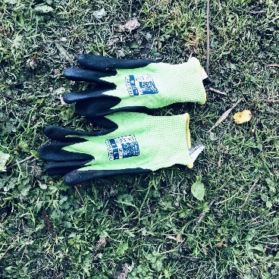
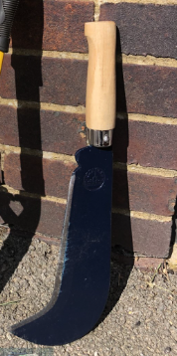

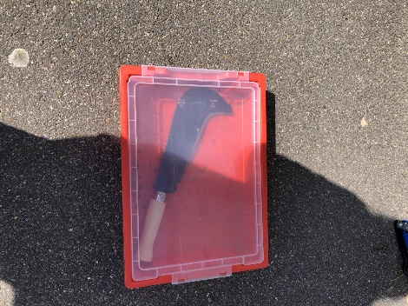

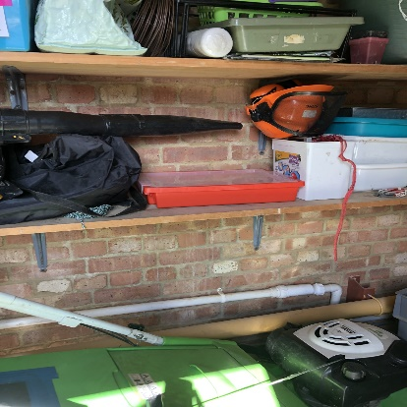

Bowsaw
Use: Sawing thicker pieces of wood/ branches
Maintenance: Bowsaw should be wiped clean after use and covered in protective casing. It should be stored and hung in locked shed (double key).
How to use tool safely
- Cut proof gloves to be worn.
- Use a cutting horse or secure wood, if using a longer branch, by someone else holding the opposite end of the wood securely and stopping the wood from moving.
- Hold the handle of the bowsaw, do not touch the blade. Place one hand through the bowsaw to secure the wood. Use dominant hand to saw. Saw a small ridge in area intended to cut. Use the whole length of the saw to begin sawing until the blade cuts through the piece of wood. Place the bowsaw down. Put the protective cap over the blade.
- If assisting a child with Bowsaw. Child will need to wear cut-proof gloves. Child will hold the handle and place their other hand behind their back. Forest School practitioner will hold the opposite side of the bowsaw and place other hand through the bowsaw to secure the wood. Count to three and begin to saw.
- Adult: Child ratio = 1:1.
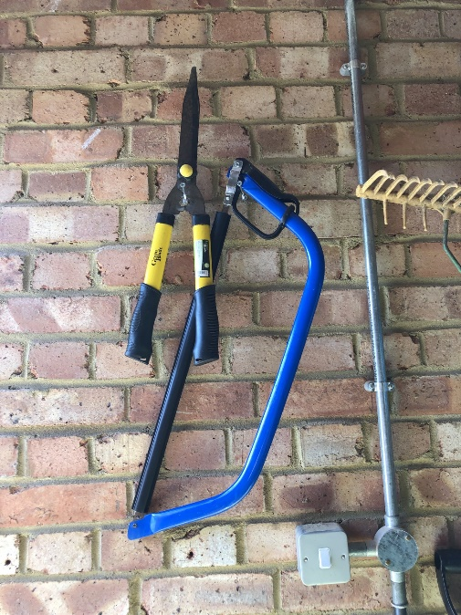
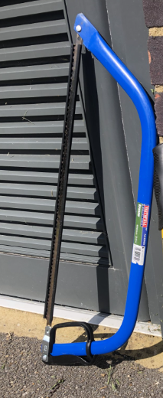

Junior hacksaw
Use: To saw small pieces of wood.
Maintenance: cleaned, dried, and stored in container and locked in cupboard. Check wear and tear regularly. Blades to be replaced when needed.
How to use safely
- Cut- proof gloves to be worn on both hands.
- Grip the handle and place blade over wood. Ensure that the wood is secure and use the whole blade to saw through the wood.
- Adult: Child ratio = 1:1

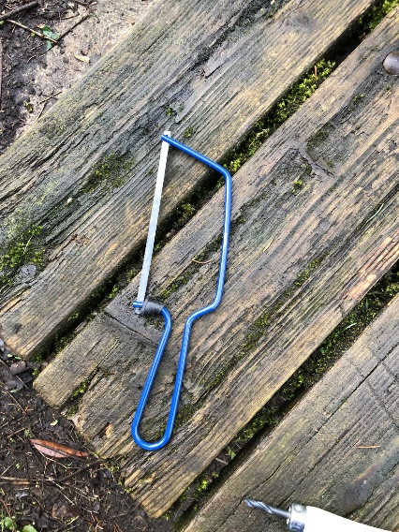

Wooden mallet:
Use: To provide a force to tools that split wood.
Maintenance: Mallet needs to be brushed down after use. It should be stored away, dry and in a container. Check for splits and check that mallet is in good working order before use.

How to use it safely
- To hammer wooden pegs into ground, hold handle and tap pegs using the head of the mallet. Make sure other hand is not near the peg.
- To use with billhook, hold mallet by the handle (see billhook tool sheet), ensure that the billhook is securely in place and tap the mallet onto the top (non- blade) part of the billhook.
- Adult: child ratio = 1:1.

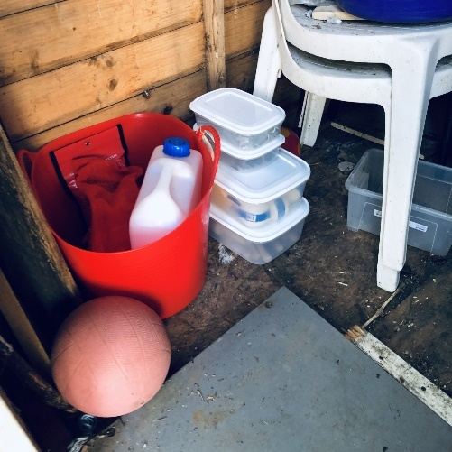
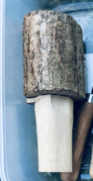
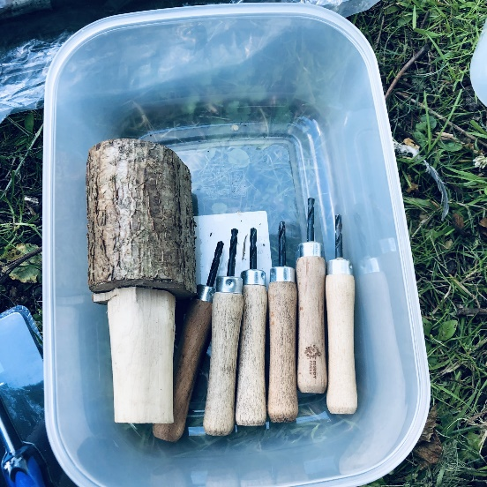

Potatoe/ vegetable peeler
Use: Can be used to strip back small twigs and branches (whittling).

Maintenance: Wipe clean and dry when finished with – replace when worn out. The peelers will be kept in a container, locked in shed.

How to use safely:
- Glove on non-working (non-tool) hand.
- Position - Sitting down on log in log-circle facing towards firepit. Either knees bent and apart, elbows on knees and hands in the middle or with both knees together to the side and hands over the top the same way as the knees.
- Strip away from the body ensuring they have enough working space to carry out this activity safely.
- Peelers to be carried pointing down.
- Adult: Child ratio = 1: 2 (years 1 and 2) and 1: 5 (years 3-6)

Loppers
Use: Loppers can be used to cut branches from finger size to 50p diameter
Maintenance: Clean after use and use a diamond file to sharpen blades, use in a circular motion at a 20-degree angle. Check all moving parts and handles for general wear and tear.
Loppers will be stored- hung up and locked away after each session.

How to use safely:
- Loppers must be carried closed at hip height and by holding the lower arm, so the blades stay closed whilst moving around the site.
- The branch should be placed firmly as far as possible into the back of the blades(beak) both hands are then used to close the handles and to cut the branch.
- Assist children to cut branches by placing hands-on top of the child’s hands and helping them to the cut the branch.
- Adult: Child ratio = 1:1.
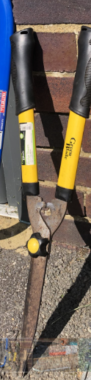

Palm Drills
Use: Drilling holes

Maintenance: Drills should be cleaned and dried and stored in a box. Each palm drill will be counted in at the end of each session and locked away in the shed.

How to use safely:
- Children should be seated, standing still, knelt and working over a log.
- A glove must be worn on non-working hand.
- Palm drill should not be used in lap (risk of incision in leg).
- Palm drill should be used on a sturdy flat surface such as a log.
- Hold the handle of the palm drill and twist the drill into the wood to create a hole.
- No walking around with tool.
- Adult: Child ratio = 1: 2 (years 1 and 2) and 1: 5 (years 3-6).

Secateurs
Use: Can be used to cut branches and twigs up to finger size in diameter.

Maintenance: Secateurs should be kept container. They should be cleaned and dried before storing away in locked shed.

How to use safely.
- They must be carried in a gloved hand with the blades facing down and locked shut (adults only).
- The twig should be placed firmly into the blades and cut using a scissor motion.
- A glove must be worn on the non-working hand.
- The safety lock must be used when the tool is not in use.
- Adult: Child ratio = 1:1.

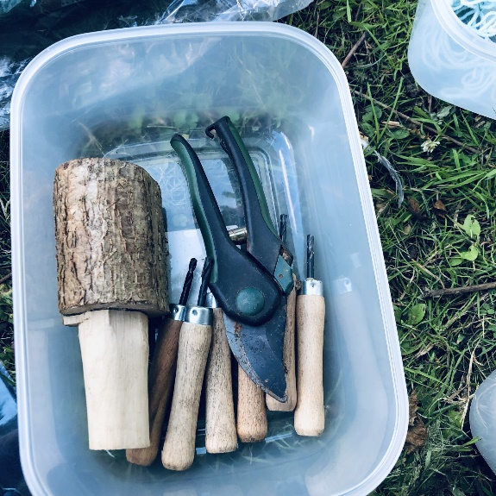

Bradawl
Use: to create a hole in wood.
Maintenance: Cleaned after use, dried, and stored in a container in locked shed.

How to use safely:
- Glove on non-working hand.
- Hold handle and place the bradawl on the wood where the hole is wanted and push firmly into the wood. Twist the bradawl back and forth repeatedly whilst pressing down to create hole.
- Adult: Child ratio = 1:1
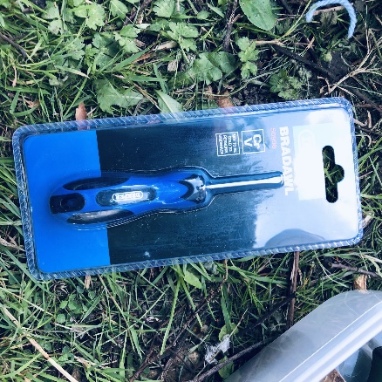
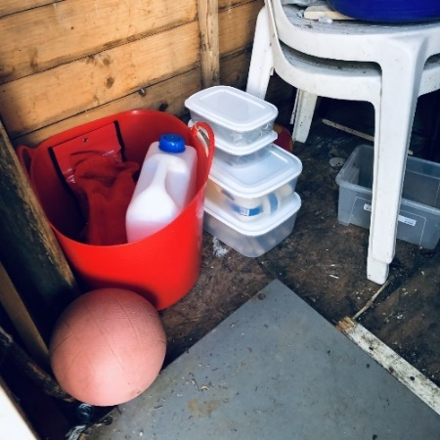
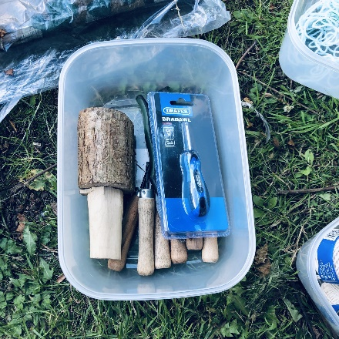

Appendix

Incident Log Form
Complete the form for every accident leading to injury, violent or aggressive incident, ill health, disease or near miss.

Date and time of incident: Location:
Person injured or subject to aggression:
Was the incident:
- A near miss
- An accident leading to injury
- Ill health/ disease
- A violent or aggressive incident

What happened?

Was anyone else involved?

Was anything damaged?

Name of the person completing the form:

Date of completing this form:

Forest School Handbook Agreement
I confirm that I have read a copy of this Handbook and agree to abide by the policies and procedures it contains.
Name | Organisation | Signature | Date

