Otters Homework Term 1 Week 4
English
Punctuate this letter correctly using full stops, a question mark or exclamation mark.

. ? !

Dear Humphrey
I am writing to you to ask if you could please stop taking out precious treasure form the ocean Could you tell us why you are taking our treasure
You know stealing is wring so why do you keep on stealing the sea creatures lovely treasure
All of the sea creatures would happy if you could give back everything you stole I'm sure you will have lots more friends of you do this
From
Miss Bone-Knell

Maths

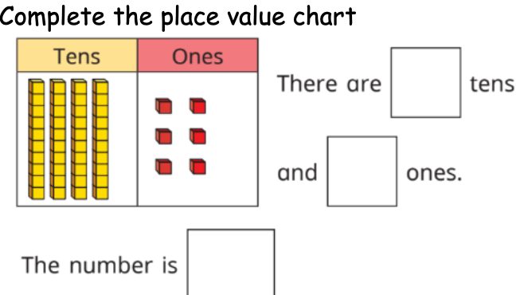

2,
3,
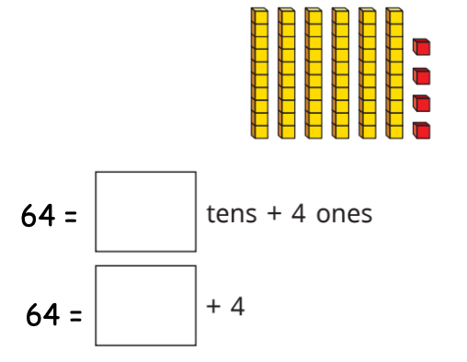.
4, …......... + 5 = 45
5, 50 + …......... = 52
6, …......... + 4 = 24
7, 10 + 9 = ….........
8, …......... + 8 = 78
9, 20 + 4 = ….........
10, …......... + 5 = 55

