13.10.23
Otters’ homework

This week in English we have been writing a non-chronological report about Ella Fitzgerald.
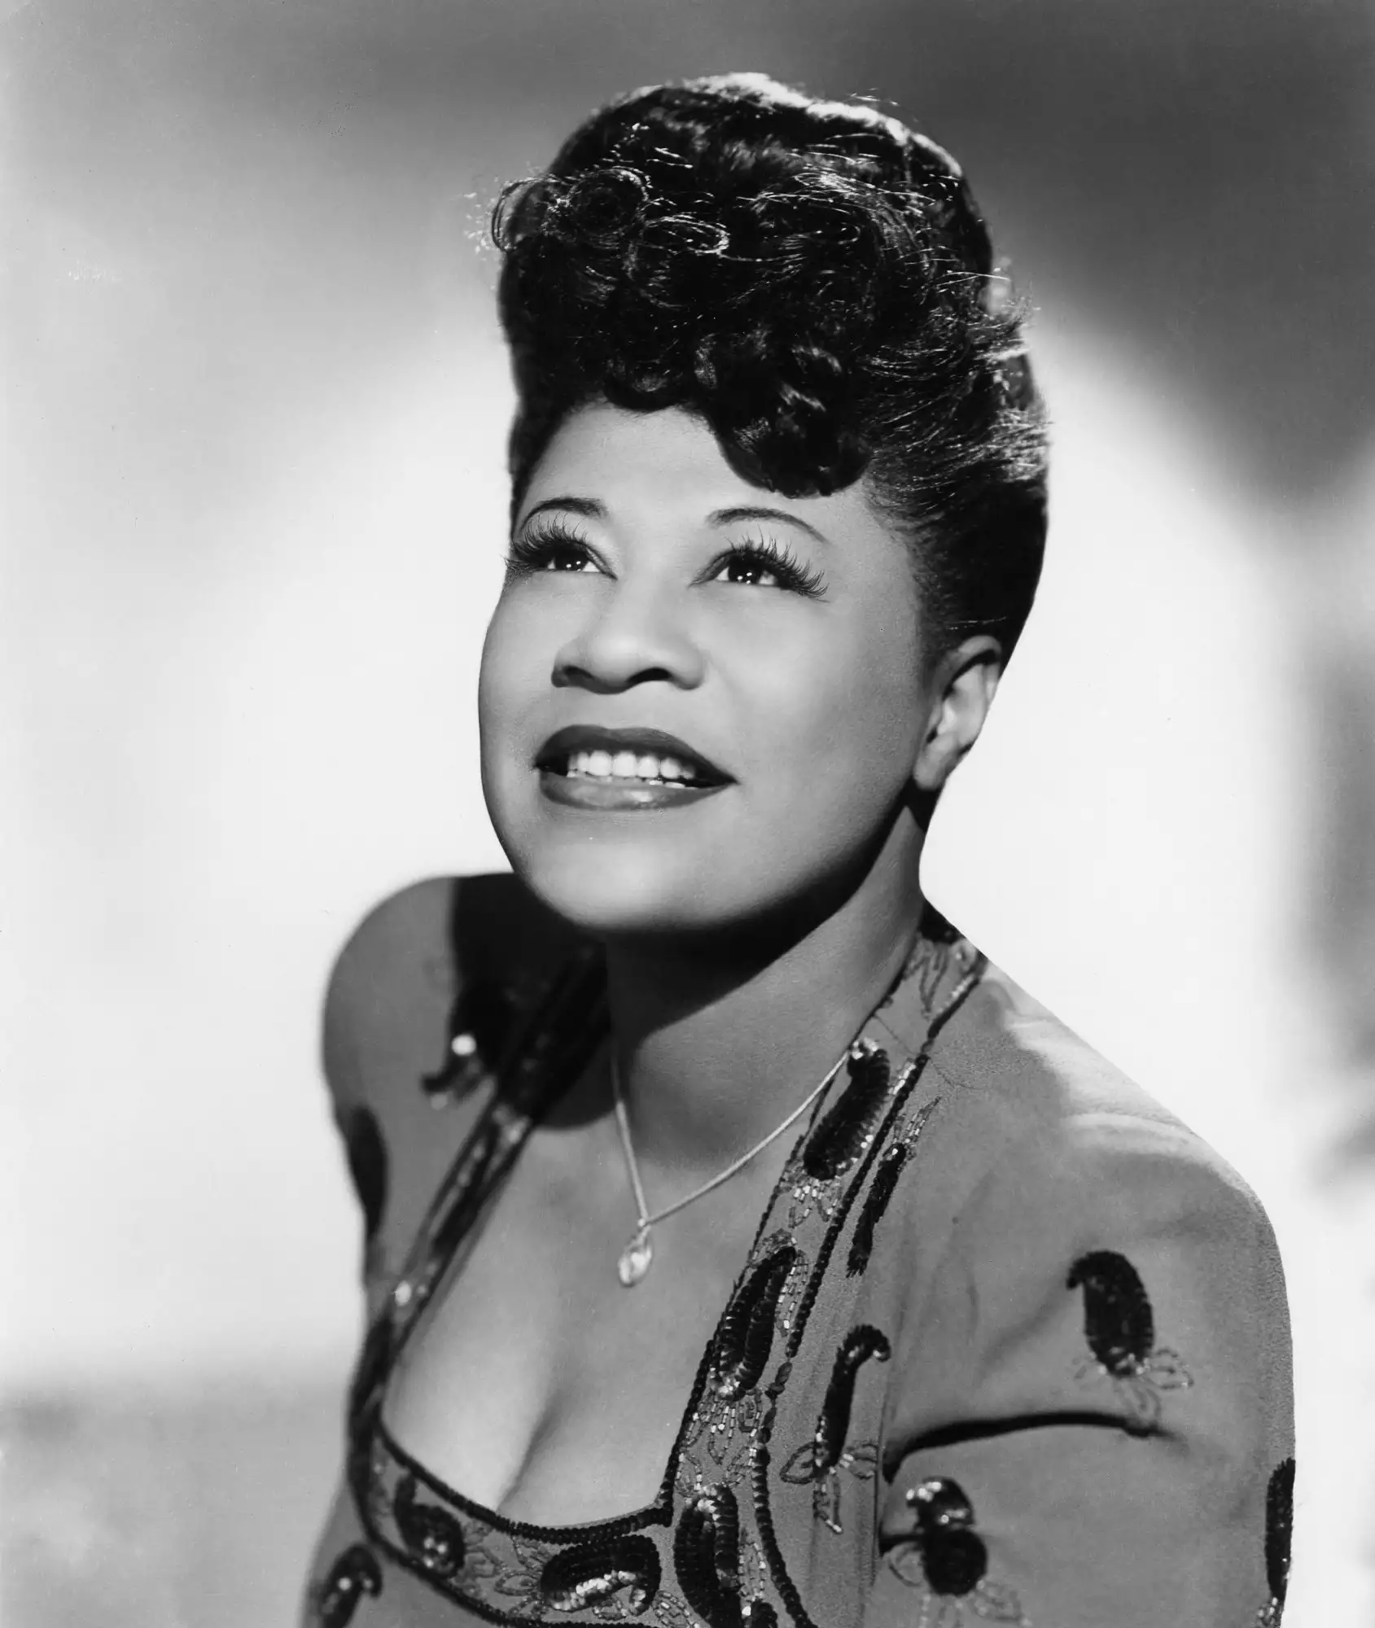

Can you write a paragraph about Ella Fitzgerald.
You could include what music she makes, what your favourite thing about her is.

Math

What number bond to 10 have you NOT written?
…………………………………………………………………………………………………

